TCS ION RIO Internship Report

Prepared by: HARSHITA PRAKASH

Date: 17-04-2025

Internship - TCS iON RIO-125: Secured Docker Based Lab: Enforcing end-to-end security

Industry mentor - Debashis Roy

## Introduction

This report details the work completed as part of the TCS ION RIO internship. The project focused on setting up a secure and scalable environment using AWS, Docker, and various security tools. The following action items were addressed:

1. AWS Setup and Configuration
2. Docker Environment Setup
3. Vulnerability Scanning and Penetration Testing

## Action Item 1: AWS Setup and Configuration

### 1.1 Objective

The objective of this action item was to configure an AWS environment, including setting up an EC2 instance and configuring the AWS CLI, to serve as the foundation for subsequent action items.

### 1.2 Approach

The following steps were taken:

1. **EC2 Instance Creation:**
   * An AmazonLinux 2 EC2 instance was launched in the ap-south-1 region using the AWS Management Console.
   * A new security group was created, allowing inbound SSH traffic (port 22) from my specific IP address for secure access.
   * An IAM role was not used.
2. **AWS CLI Configuration:**
   * The AWS CLI was installed on the EC2 instance using the following commands:  
     sudo apt update  
     sudo apt install awscli -y
   * The AWS CLI was configured using the aws configure command. The IAM user's Access Key ID and Secret Access Key were securely entered. The ap-south-1 region was selected, and the output format was set to json.

### 1.3 Logic Flow

1. The user logs into the AWS Management Console.
2. The user navigates to the EC2 service and launches a new instance.
3. The user configures the instance details, security group, and key pair.
4. The user connects to the EC2 instance using SSH.
5. The user installs and configures the AWS CLI.

### 1.4 Solutions and Templates

* **EC2 Security Group Rule (Inbound):**
  + Type: SSH
  + Port: 22
  + Source: My IP Address

### 1.5 Challenges Faced

* Ensuring the correct security group rules were in place to allow SSH access.

### 1.6 Results and Outputs

* An Ubuntu EC2 instance is running in the ap-south-1 region.
* The AWS CLI is installed and configured on the EC2 instance, verified by running the command aws ec2 describe-instances.

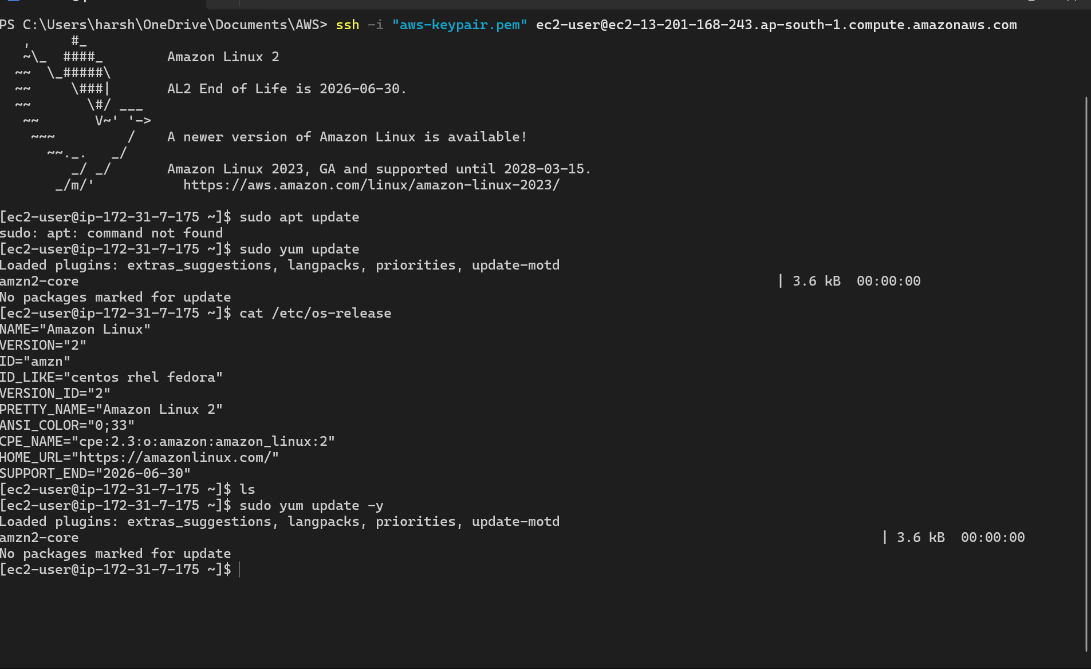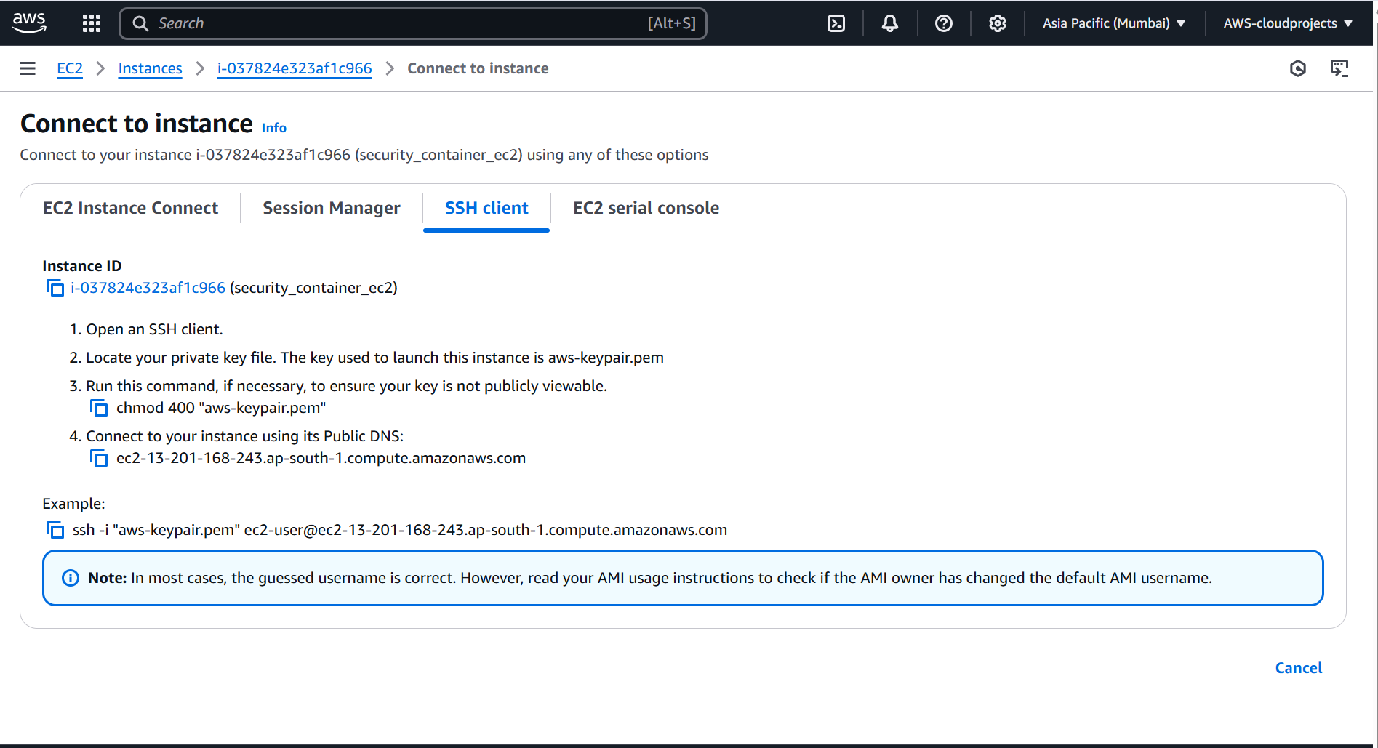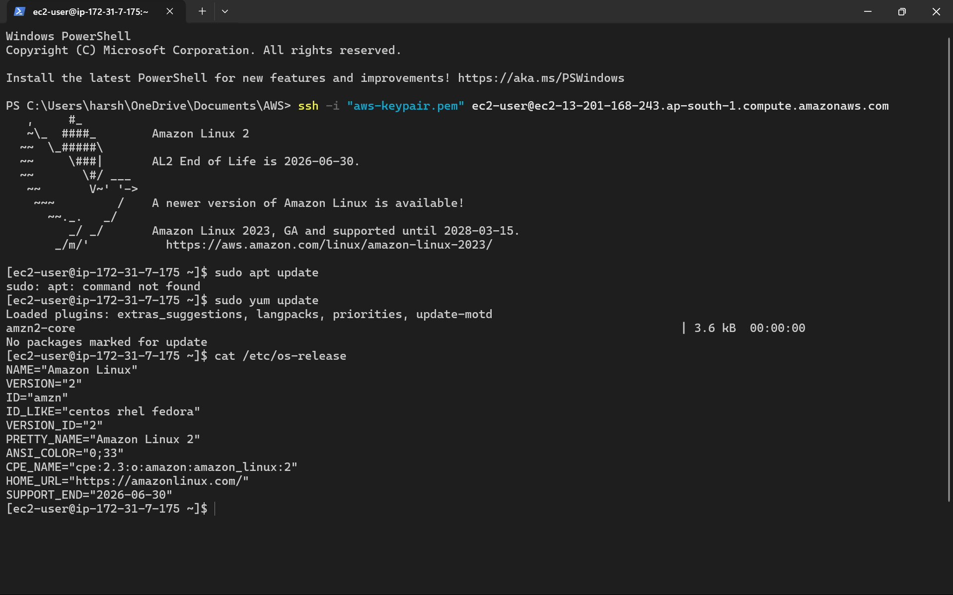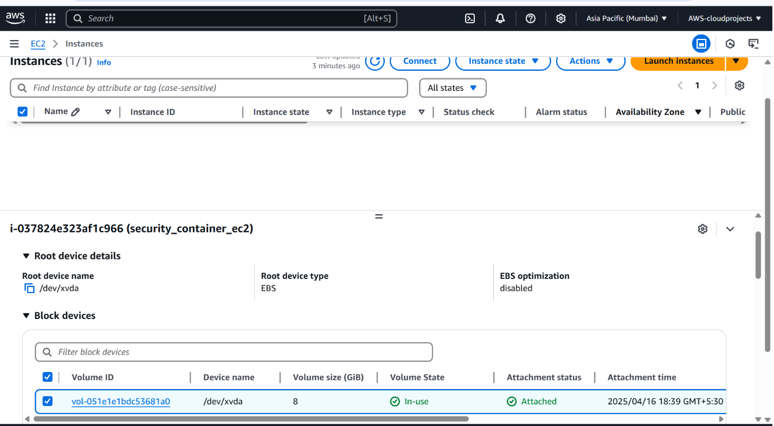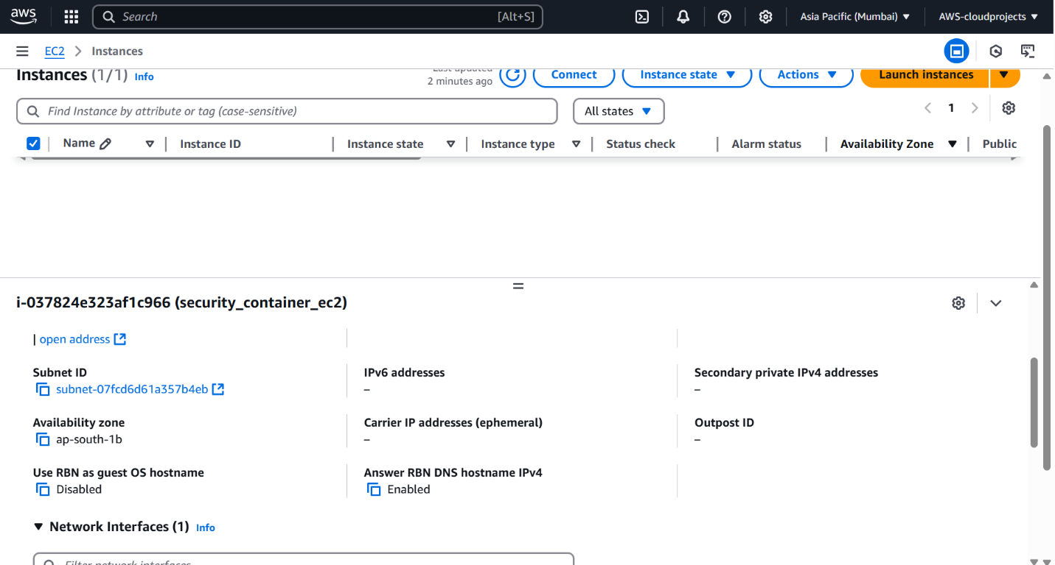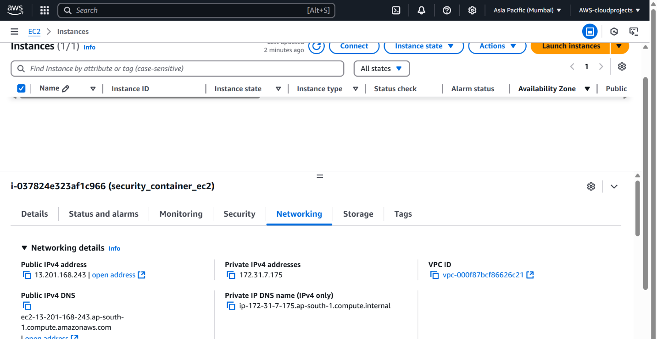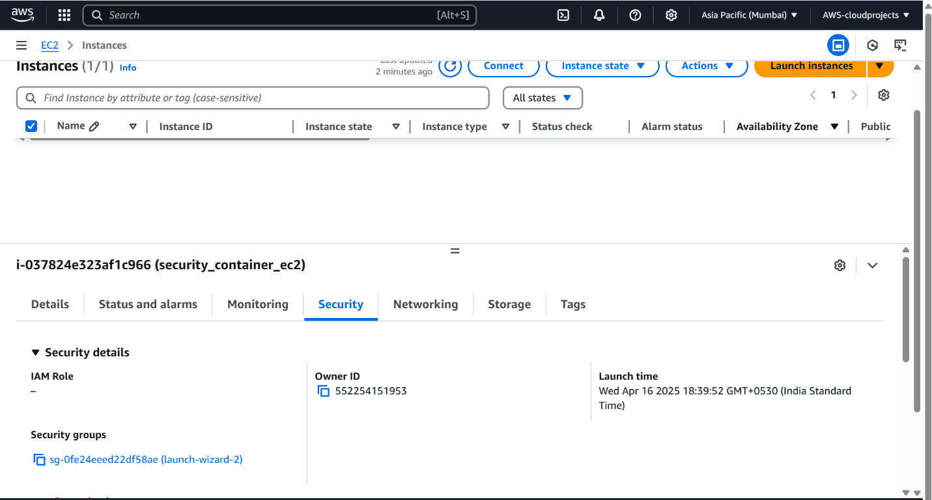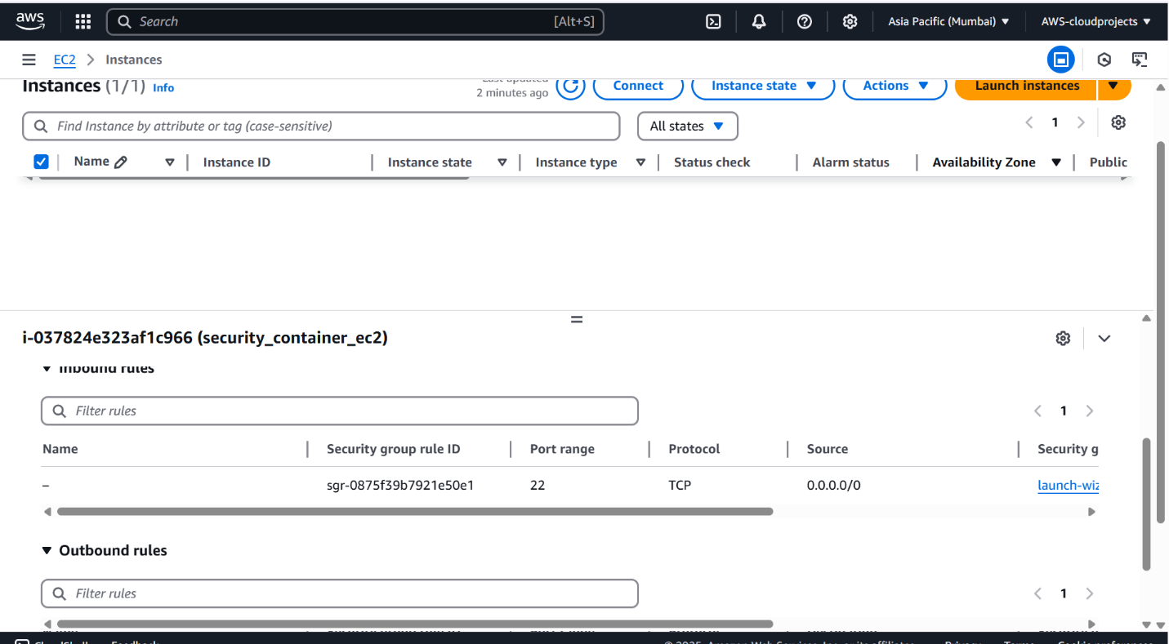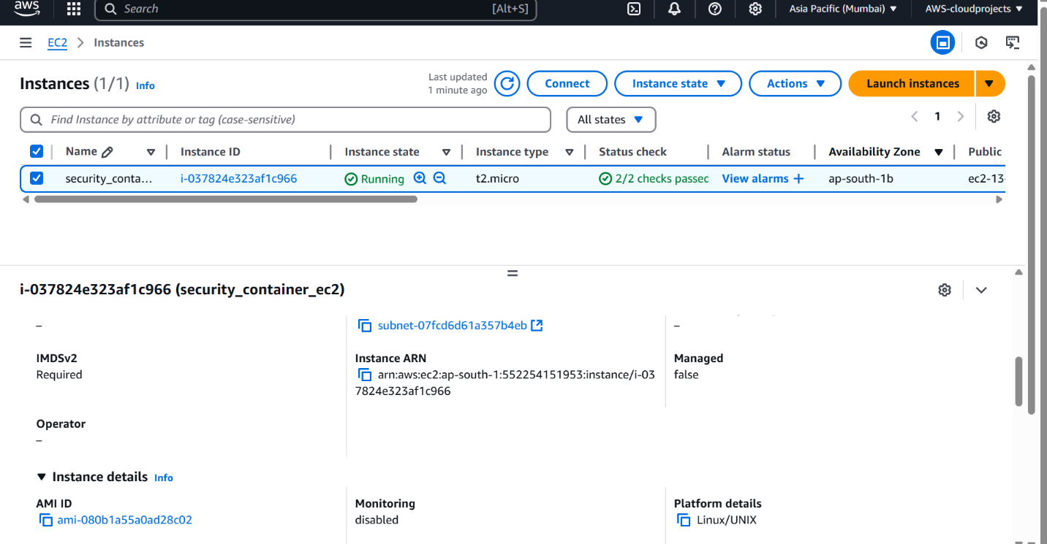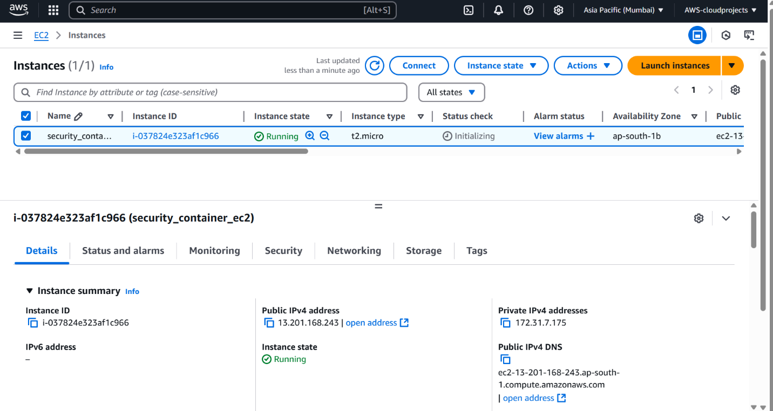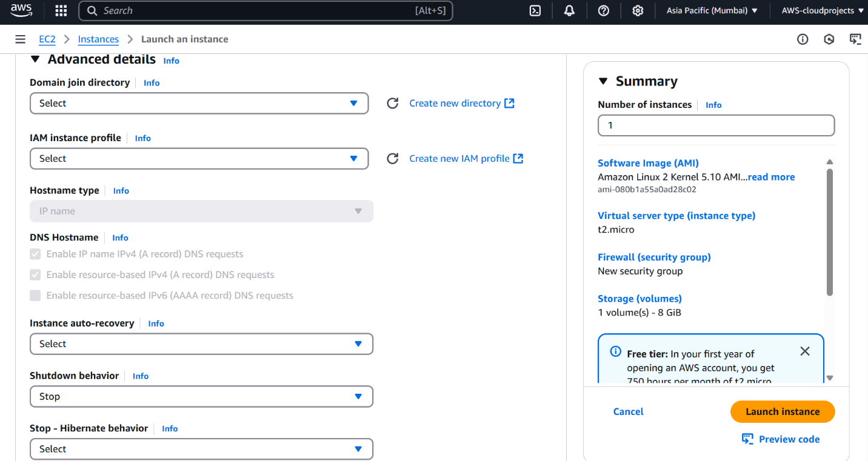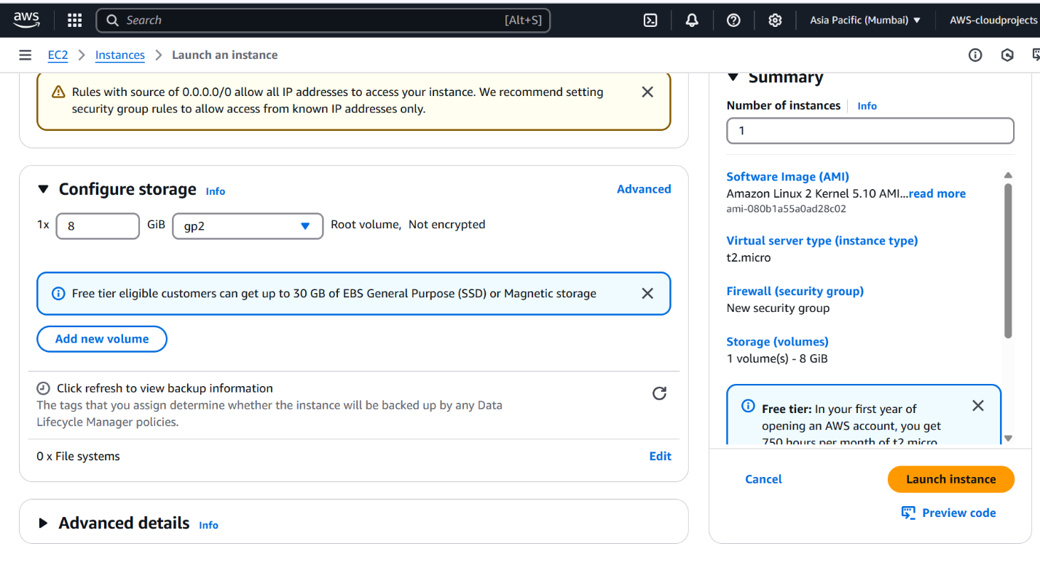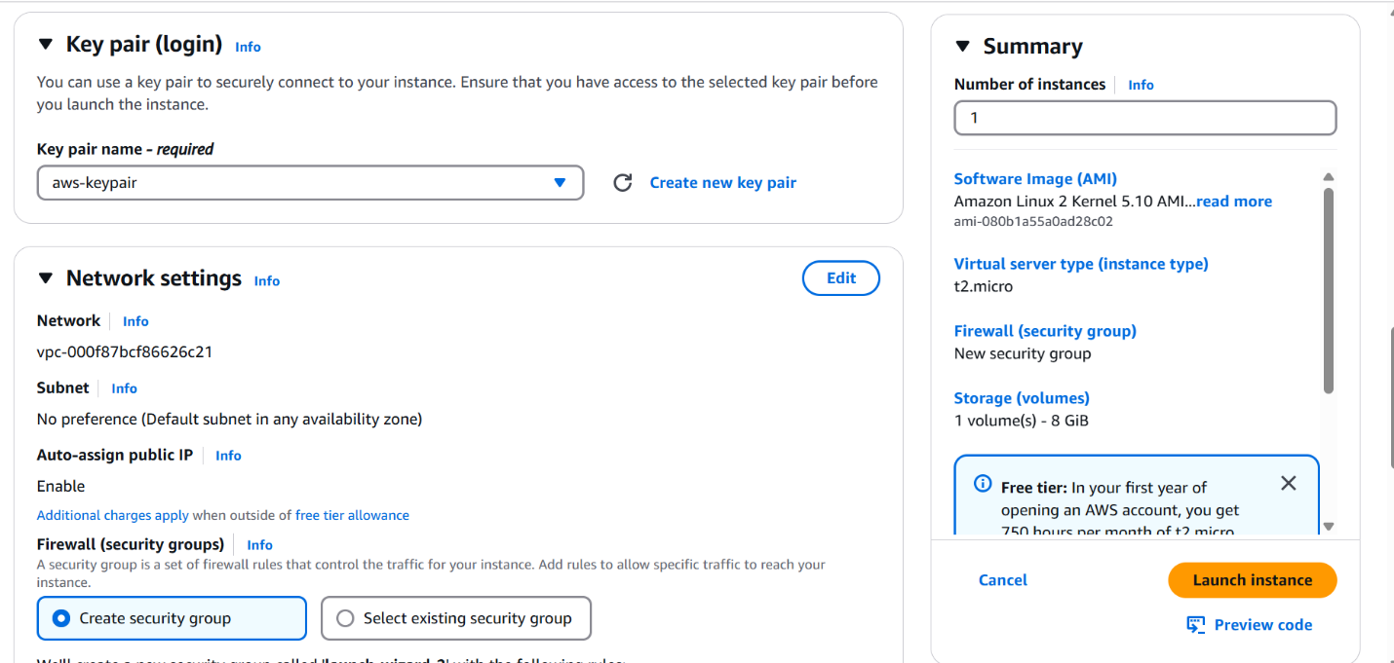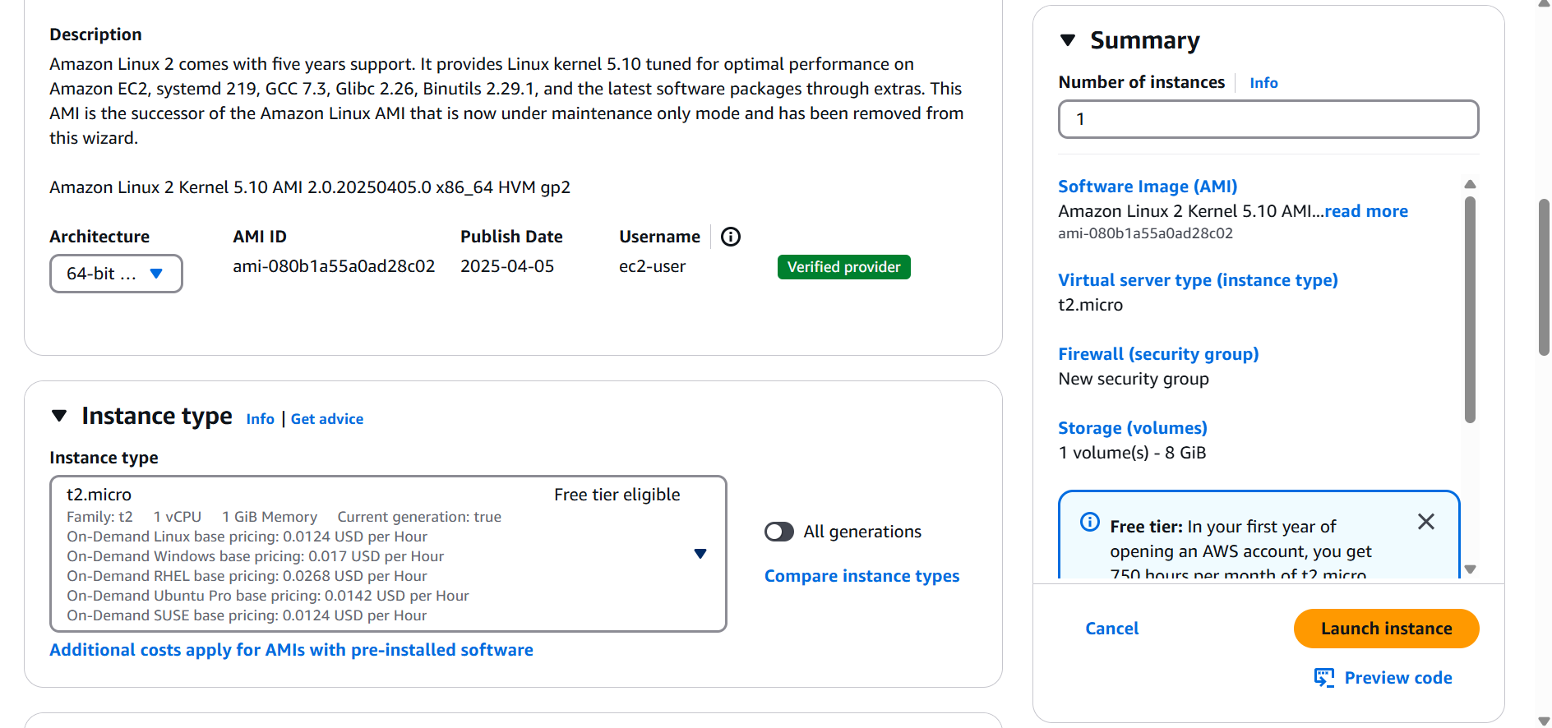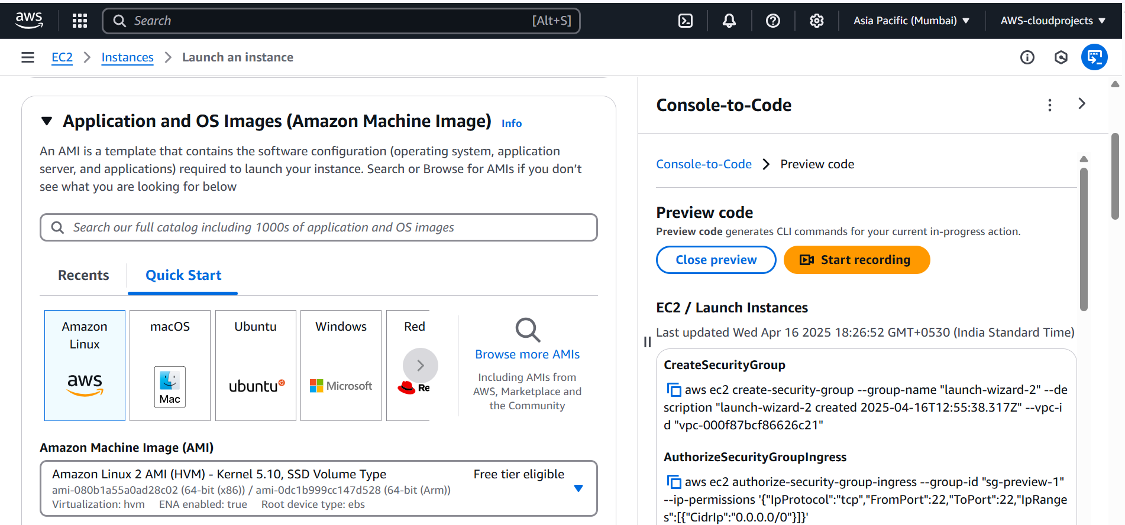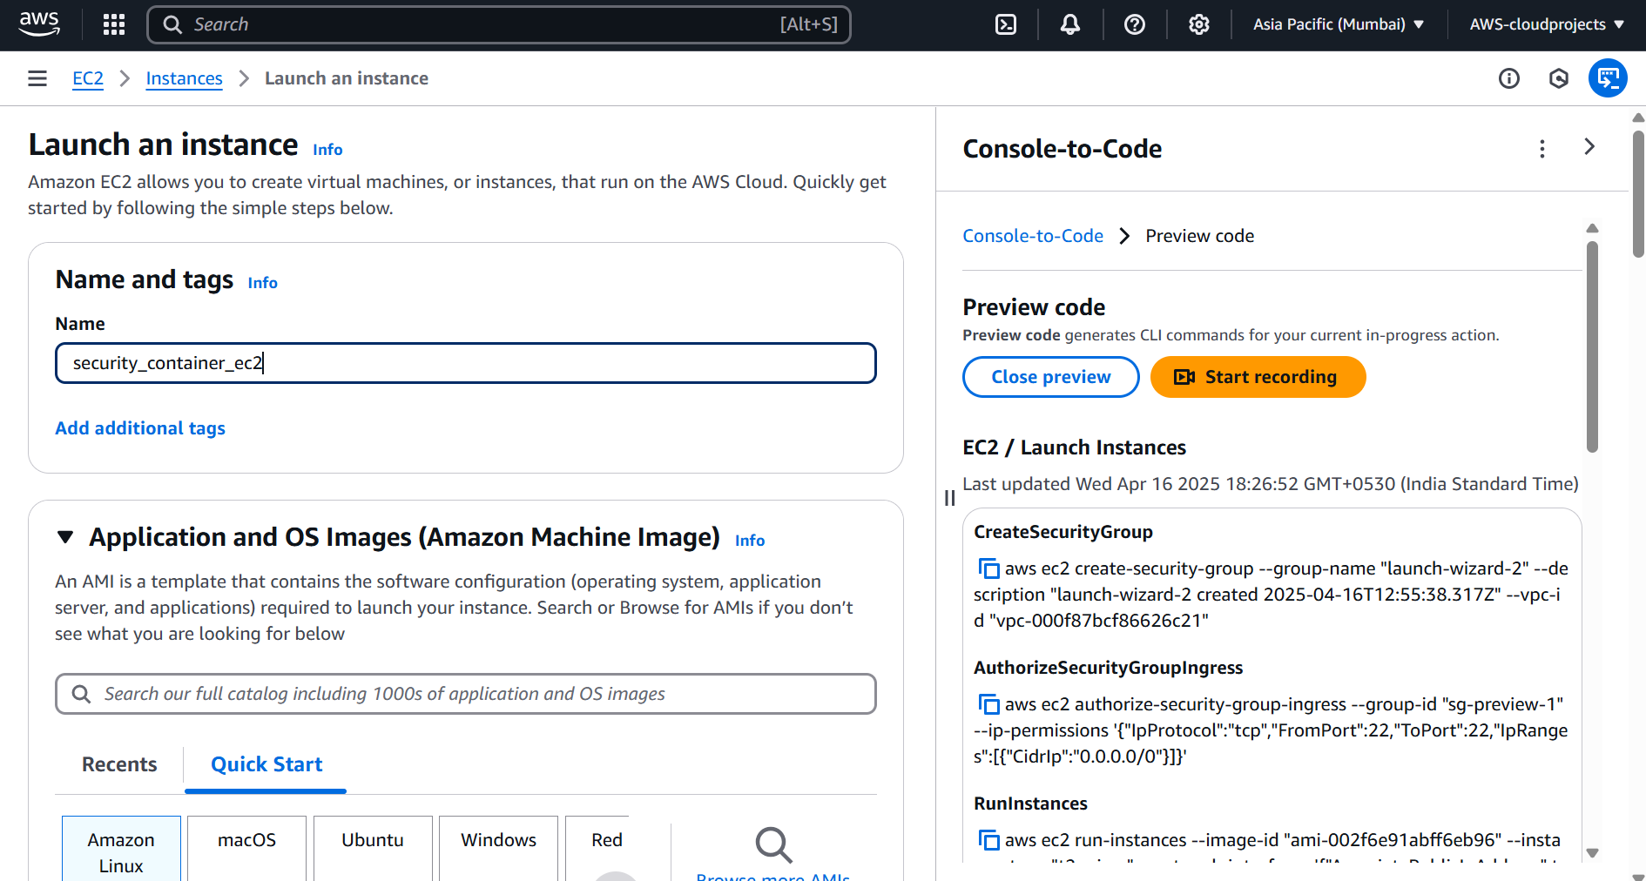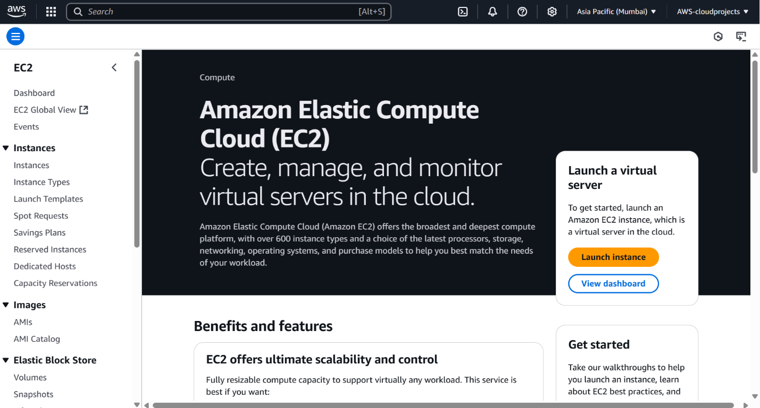

## Action Item 2: Docker Environment Setup

### 2.1 Objective

The objective of this action item was to set up a Docker environment on the EC2 instance and configure Docker Compose to manage multiple containers.

### 2.2 Approach

The following steps were taken:

1. **Docker Installation:**
   * Docker was installed on the EC2 instance using the following commands:  
     sudo yum update -y  
     sudo amazon-linux-extras install docker -y  
     sudo service docker start  
     sudo usermod -a -G docker ec2-user  
     newgrp docker
2. **Docker Compose Installation:**
   * Docker Compose v2 was installed using the following commands:  
     sudo yum install -y docker-compose-plugin  
     sudo ln -s /usr/bin/docker-compose /usr/local/bin/docker-compose
3. **Docker Compose Configuration:**
   * A docker-compose.yml file was created to define the Docker environment. The file defines the following services:
     + base_ubuntu: A base Ubuntu image.
     + python_env: A Python 3.9 environment based on the base Ubuntu image.
     + java_env: A Java 11 environment based on the base Ubuntu image.
     + web_server: An Nginx web server.
     + mysql_db: A MySQL 8.0 database.
   * A volume mount was defined for the base_ubuntu service to share files between the host and the container.

### 2.3 Logic Flow

1. The user connects to the EC2 instance via SSH.
2. The user installs Docker using yum.
3. The user installs Docker Compose v2.
4. The user creates a docker-compose.yml file defining the services.
5. The user runs docker-compose up to start the containers.

### 2.4 Solutions and Templates

**docker-compose.yml**:  
version: 'v2.35.0'

networks:

private_net:

ipam:

config:

- subnet: 172.16.0.0/16 # Define your private subnet

services:

base_ubuntu:

image: ubuntu:latest

hostname: base-os

networks:

private_net:

ipv4_address: 172.16.0.10

command: tail -f /dev/null # Keep the container running

python_env:

build:

context: ./python_app # Corrected context

dockerfile: Dockerfile-python

hostname: python-app

networks:

private_net:

ipv4_address: 172.16.0.20

ports:

- "8000:8000" # Example port for a Python web app (adjust as needed)

depends_on:

- base_ubuntu

java_env:

build:

context: ./java_app # Corrected context

dockerfile: Dockerfile-java

hostname: java-app

networks:

private_net:

ipv4_address: 172.16.0.30

ports:

- "8080:8080" # Example port for a Java web server (adjust as needed)

depends_on:

- base_ubuntu

web_server:

image: nginx:latest

hostname: web-server

networks:

private_net:

ipv4_address: 172.16.0.40

ports:

- "80:80" # Expose HTTP

- "443:443" # Expose HTTPS (if configured)

volumes:

- /home/ec2-user/lab-environment/html:/usr/share/nginx/html:ro # Mount static web content

depends_on:

- base_ubuntu

mysql_db:

image: mysql:latest

hostname: mysql-server

networks:

private_net:

ipv4_address: 172.16.0.50

environment:

MYSQL_ROOT_PASSWORD: your_root_password

# Add other MySQL environment variables as needed

ports:

- "3306:3306" # Expose MySQL port (only if needed externally)

volumes:

- mysql_data:/var/lib/mysql # Corrected volumes definition

depends_on:

- base_ubuntu

mysql_db:

image: mysql:latest

hostname: mysql-server

networks:

private_net:

ipv4_address: 172.16.0.50

environment:

MYSQL_ROOT_PASSWORD: your_root_password

# Add other MySQL environment variables as needed

ports:

- "3306:3306" # Expose MySQL port (only if needed externally)

volumes:

- mysql_data:/var/lib/mysql # Corrected volumes definition

depends_on:

- base_ubuntu

volumes:

mysql_data: # Define the named volume for MySQL data persistence

* **Dockerfile-python**:  
  FROM ubuntu:latest  
  RUN apt-get update && apt-get install -y python3 python3-pip  
  WORKDIR /app
* **Dockerfile-java**:  
  FROM ubuntu:latest  
  RUN apt-get update && apt-get install -y openjdk-11-jdk  
  WORKDIR /app

### 2.5 Challenges Faced

* Ensuring the correct Docker Compose version was installed.
* Configuring the Docker Compose file to define the services and network.

### 2.6 Results and Outputs

* A Docker environment is set up on the EC2 instance.
* Docker Compose is installed and configured.
* Five containers are running as defined in the docker-compose.yml file: base_ubuntu, python_env, java_env, web_server, and mysql_db.

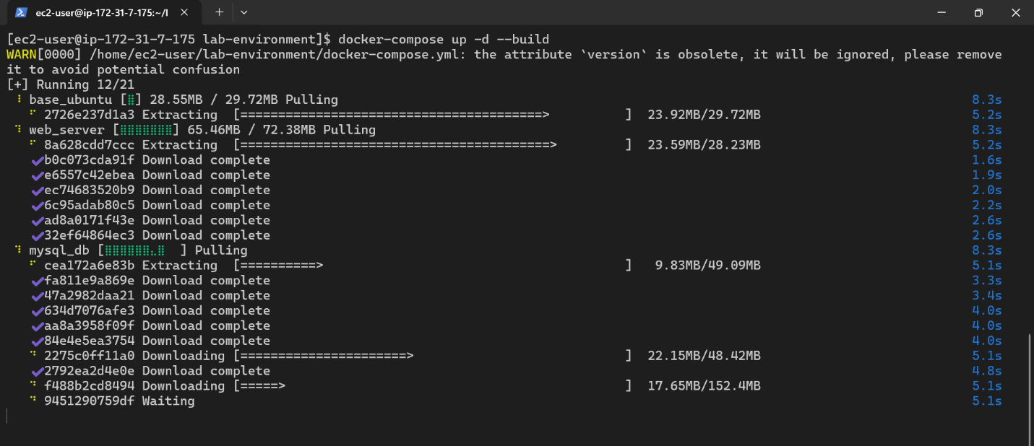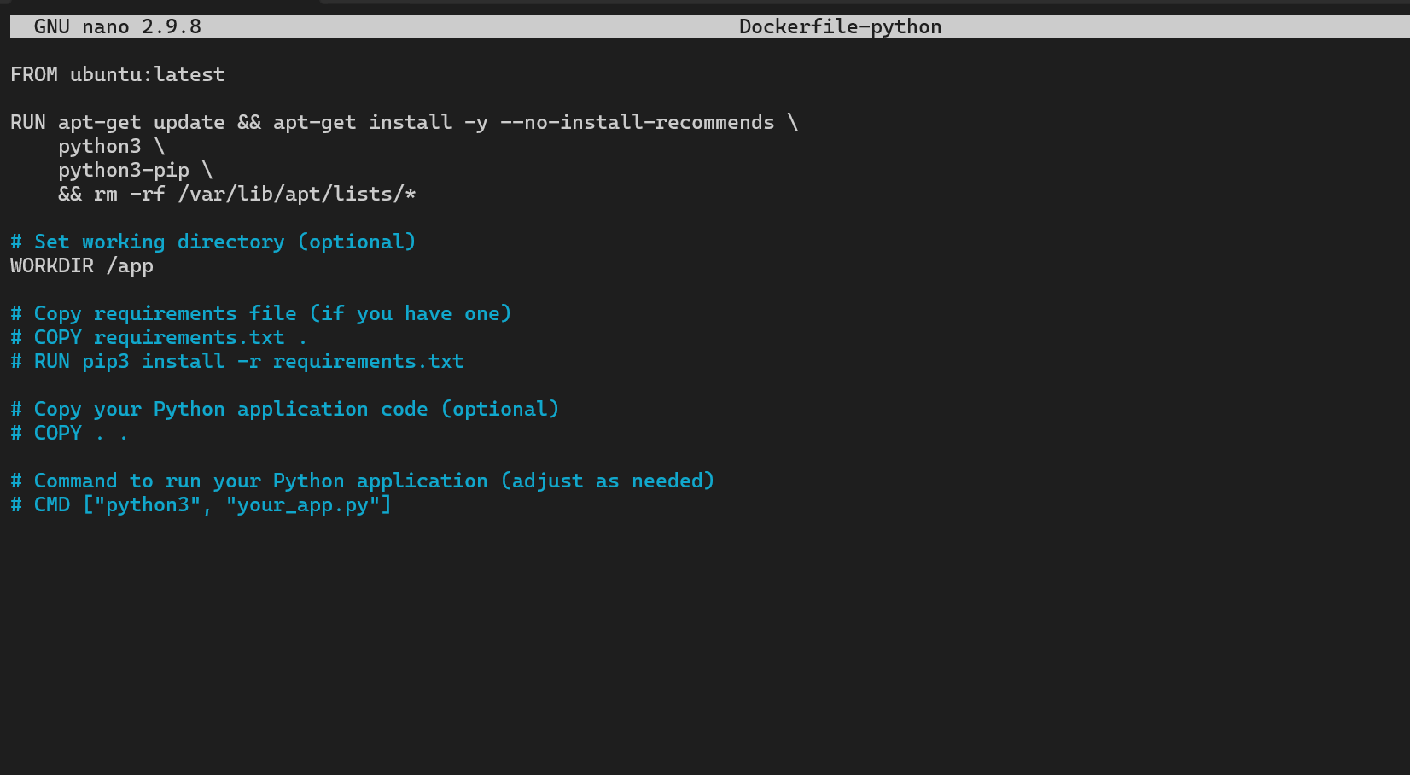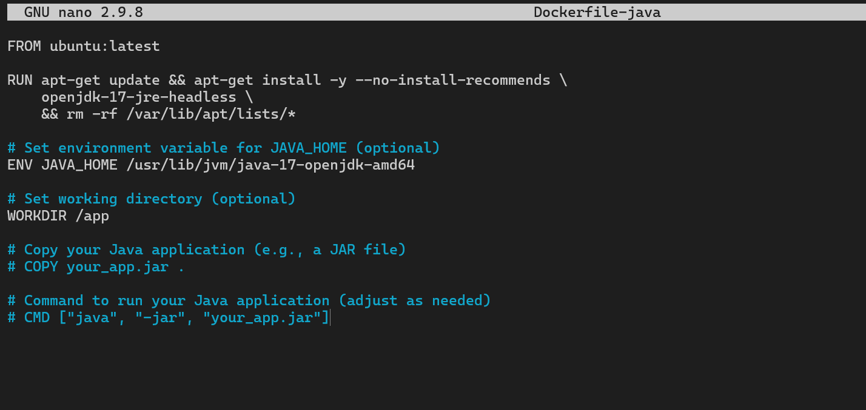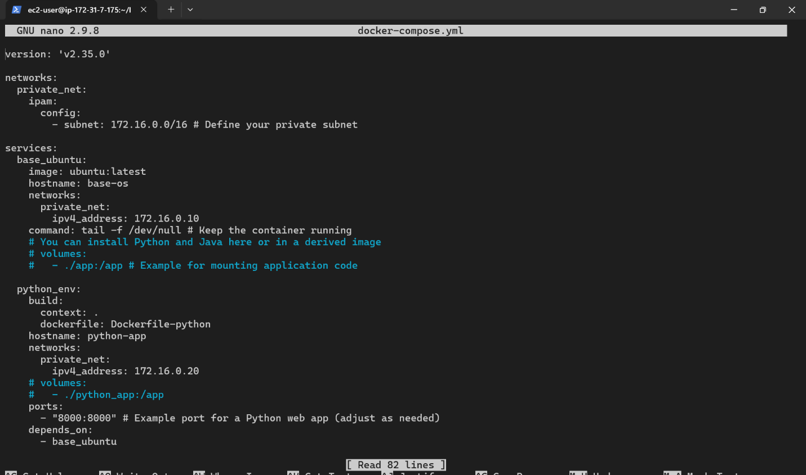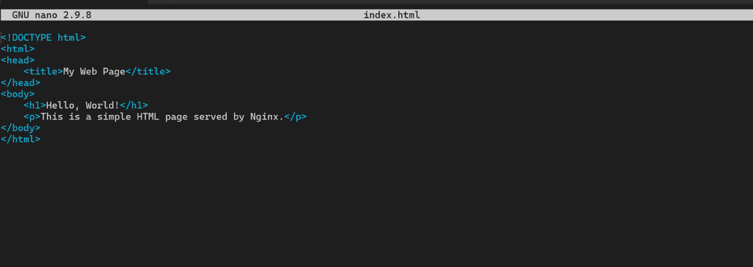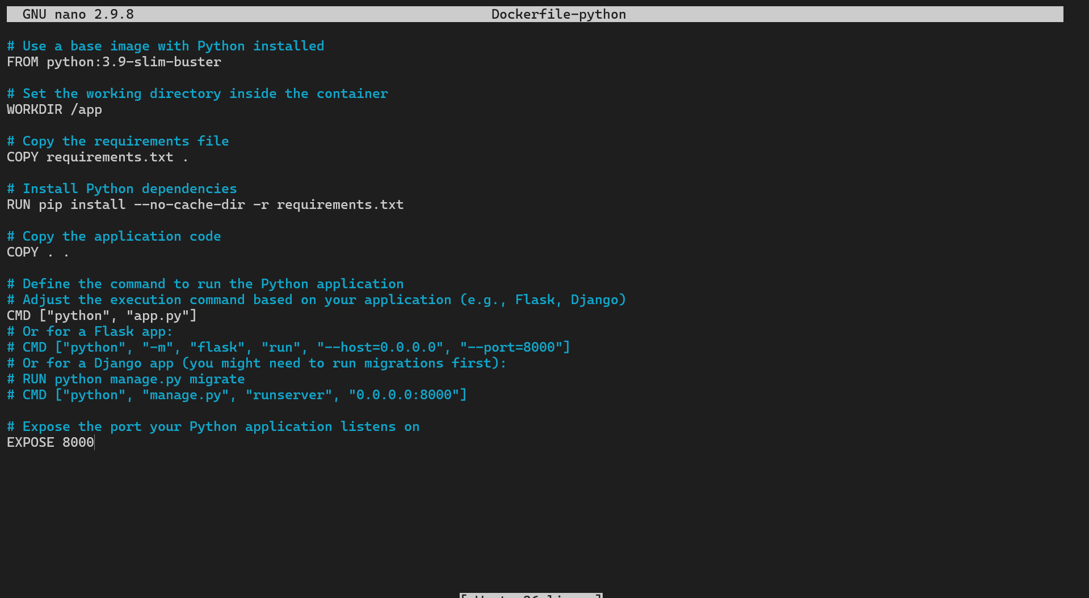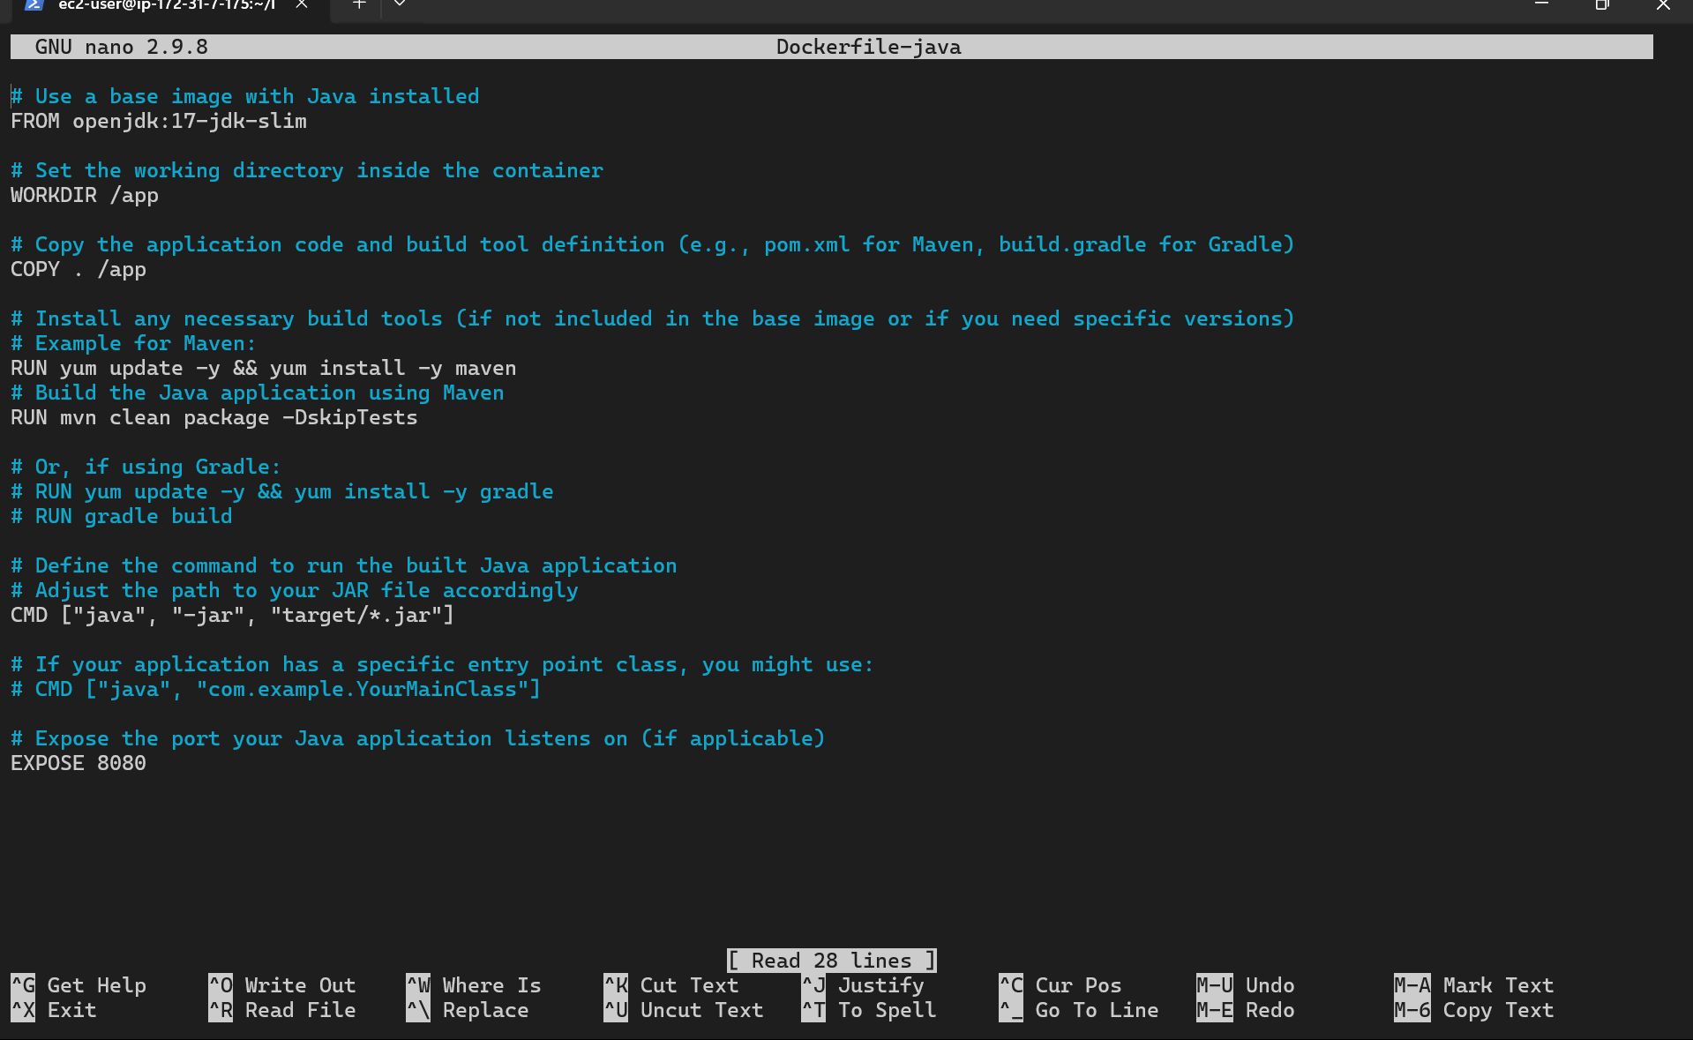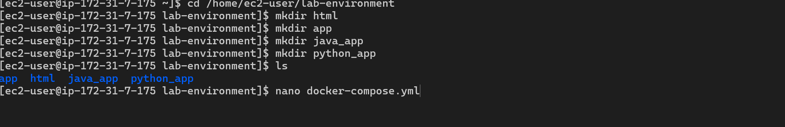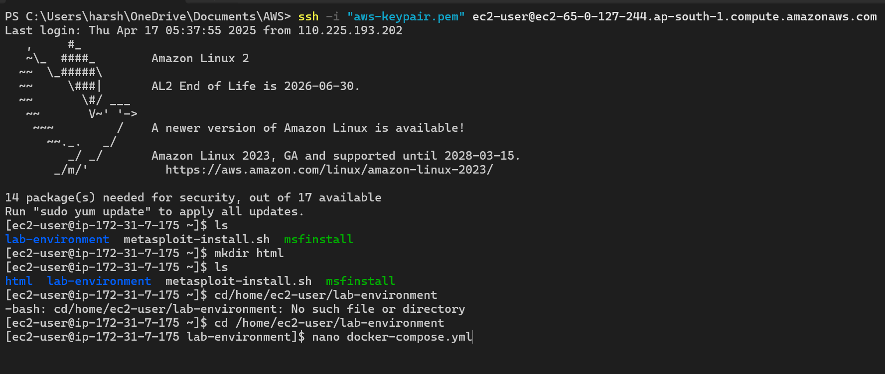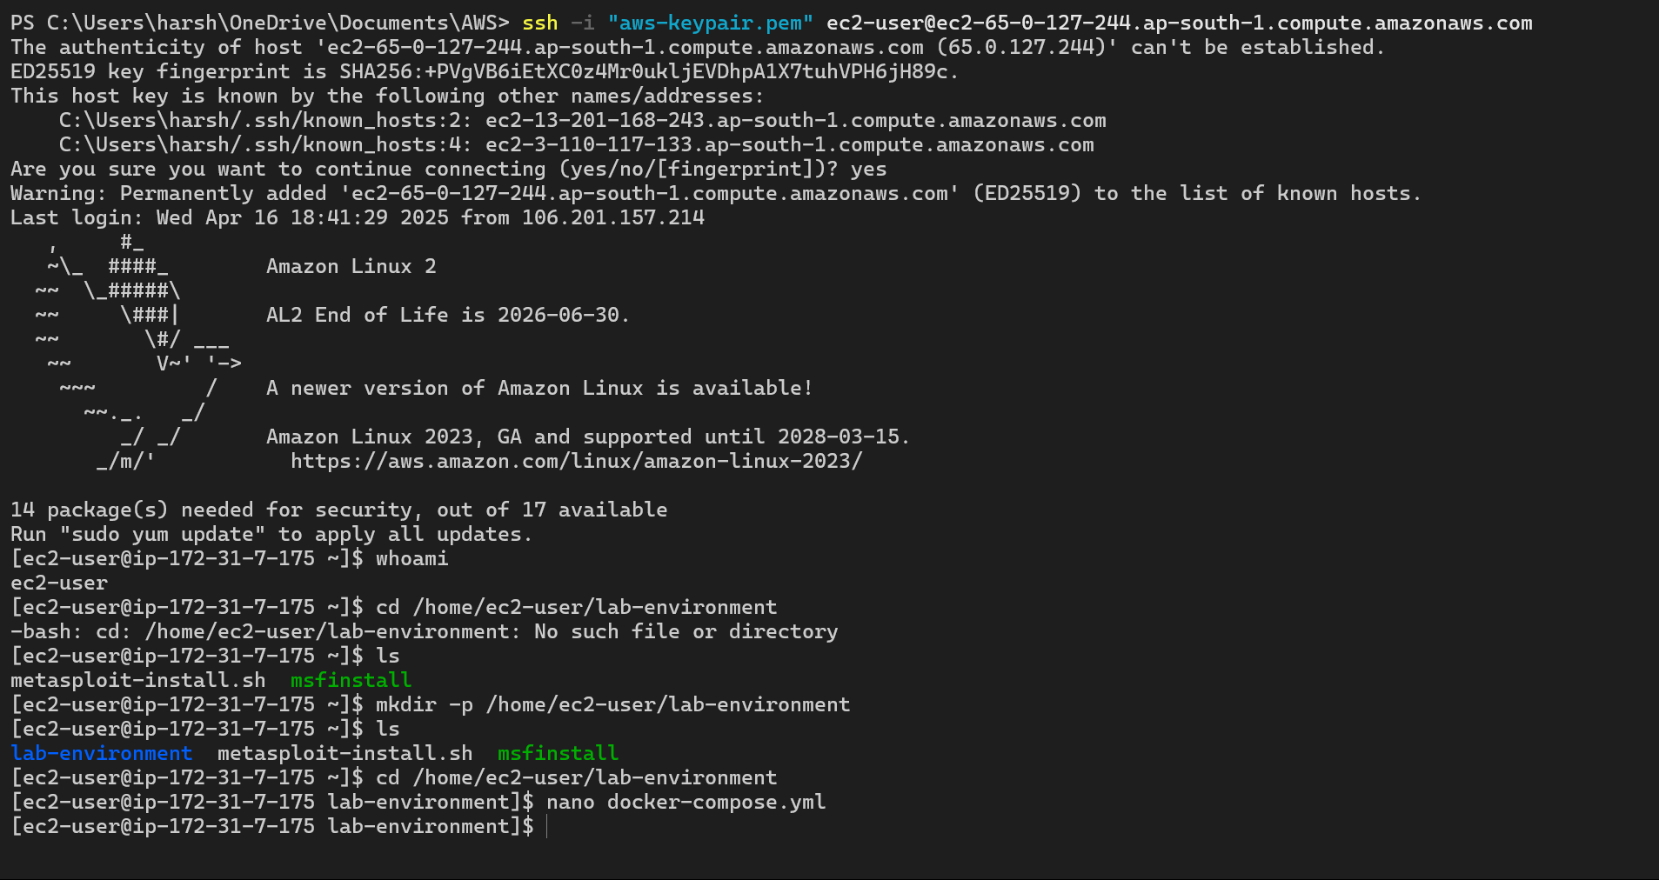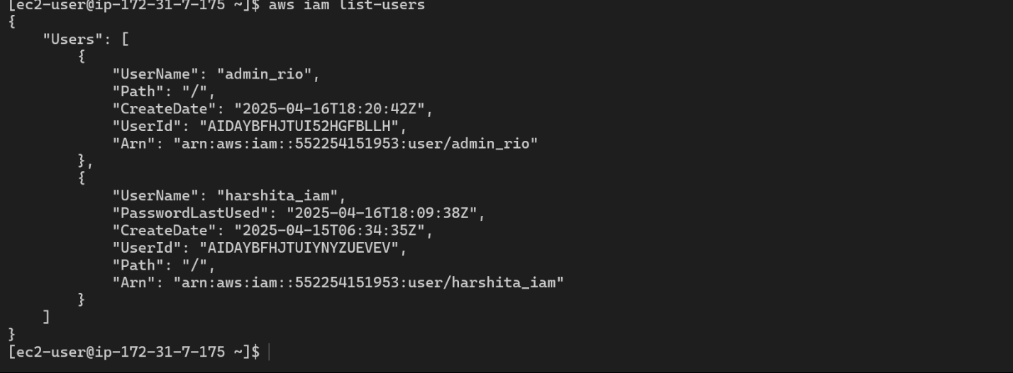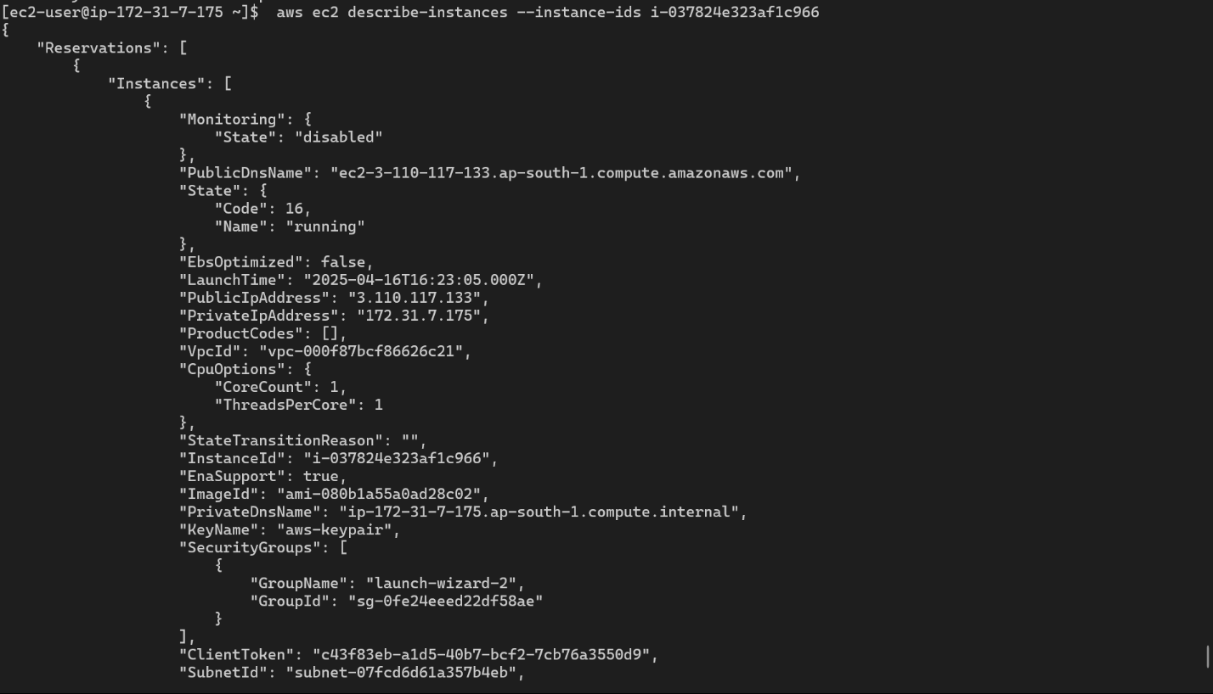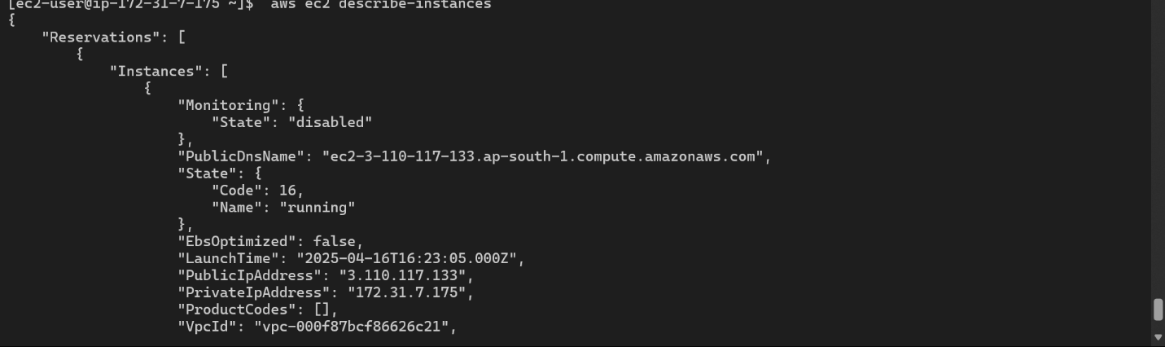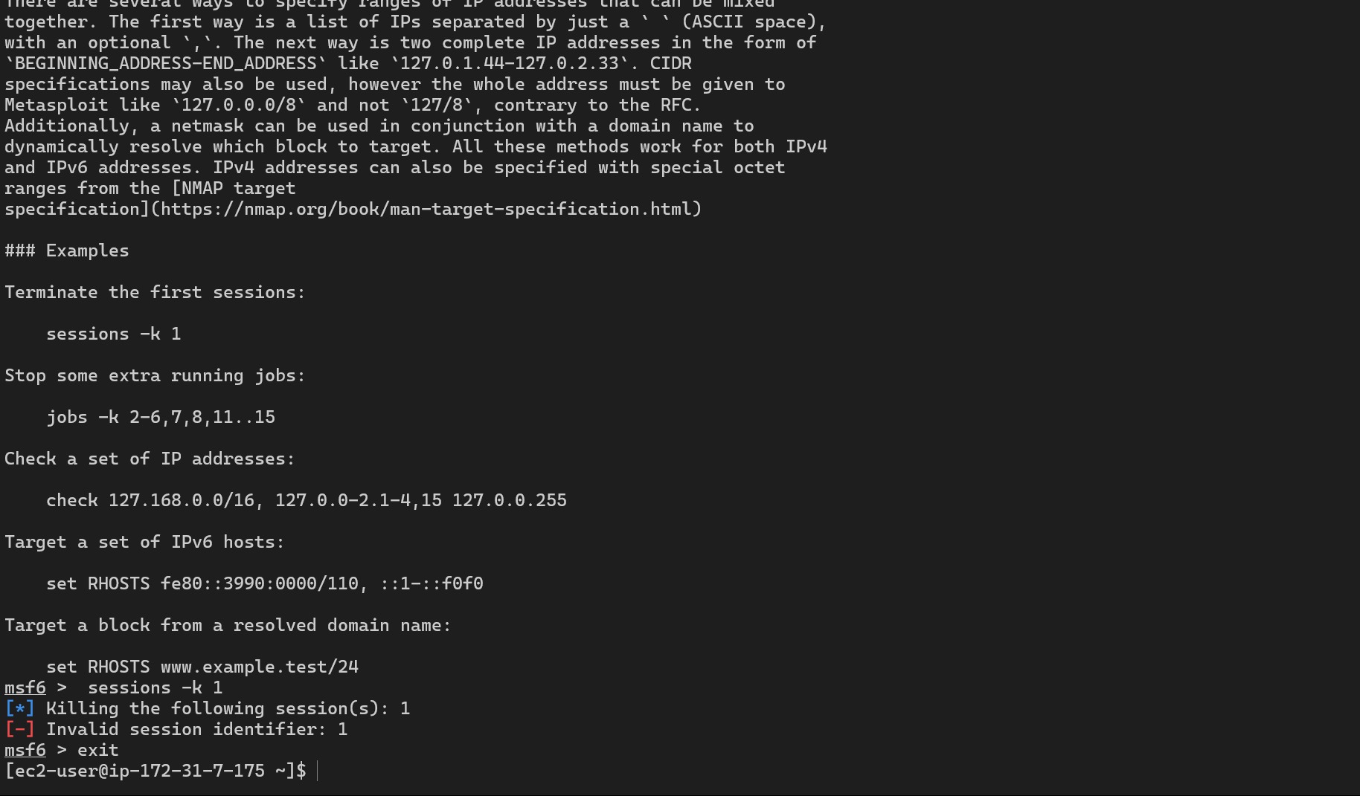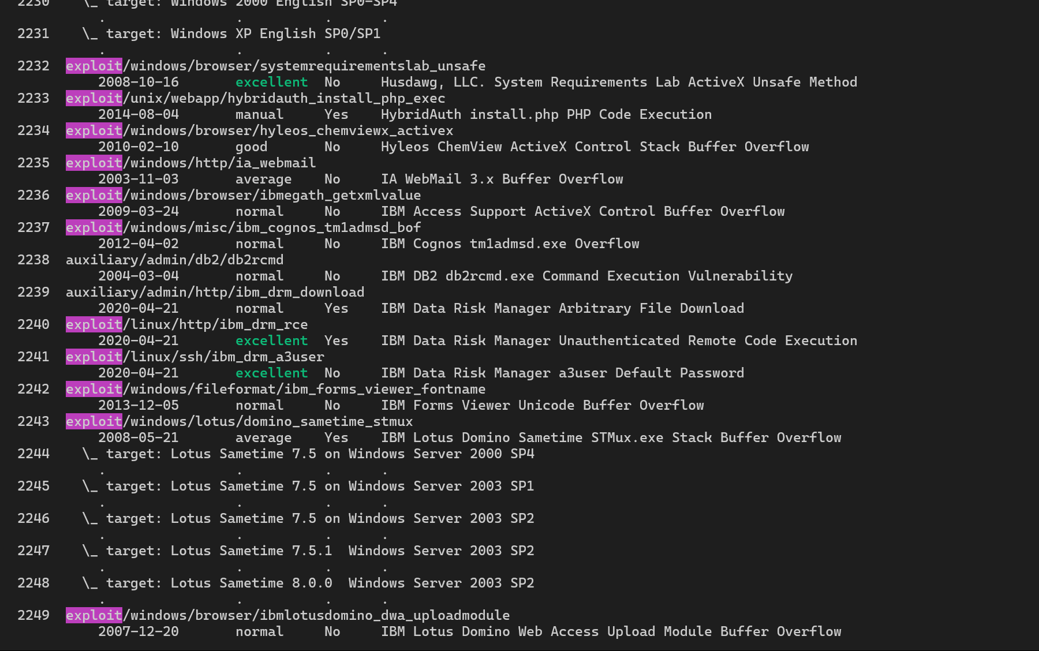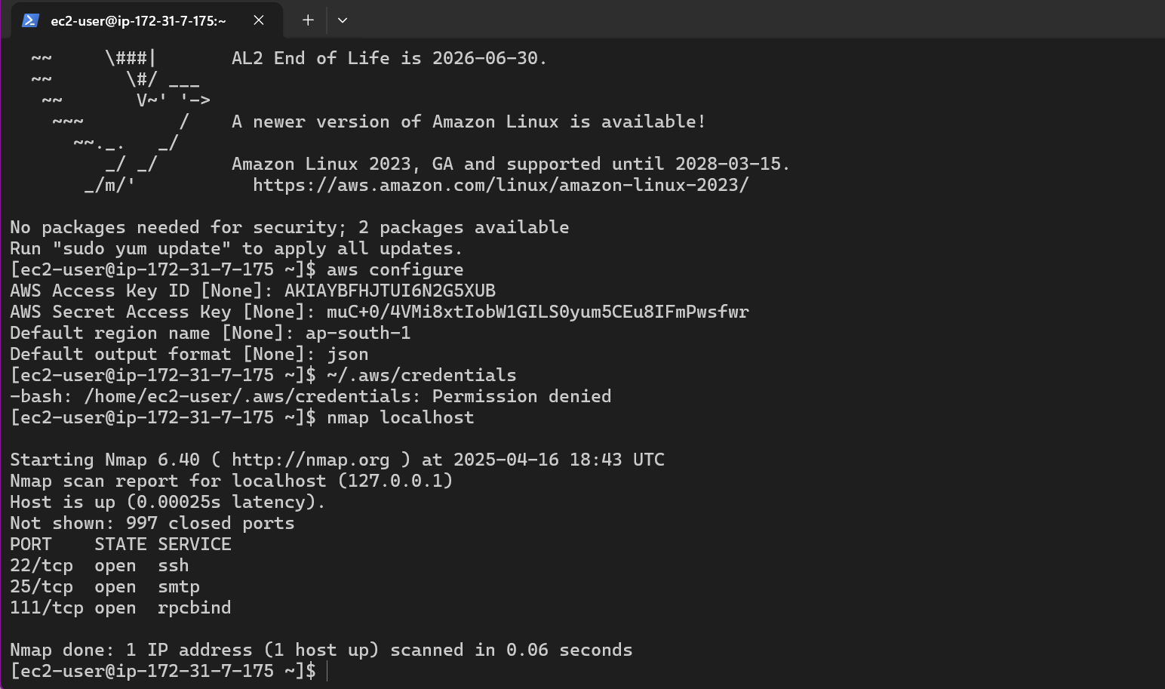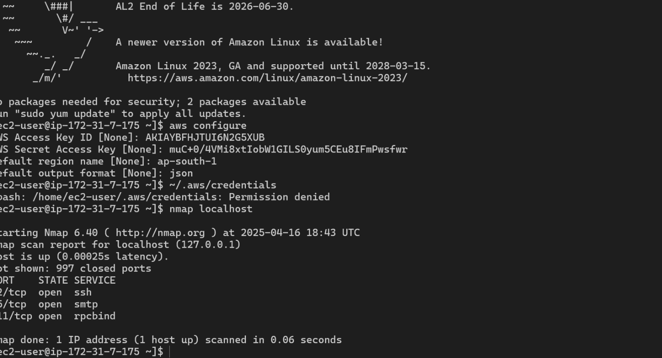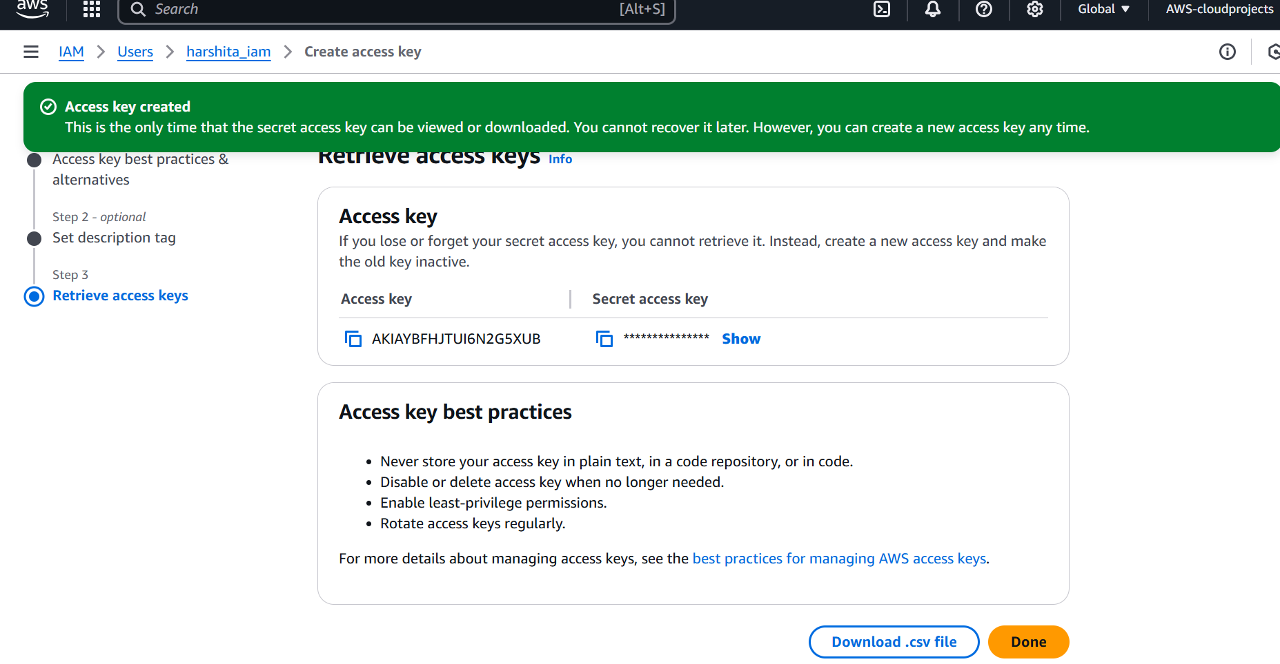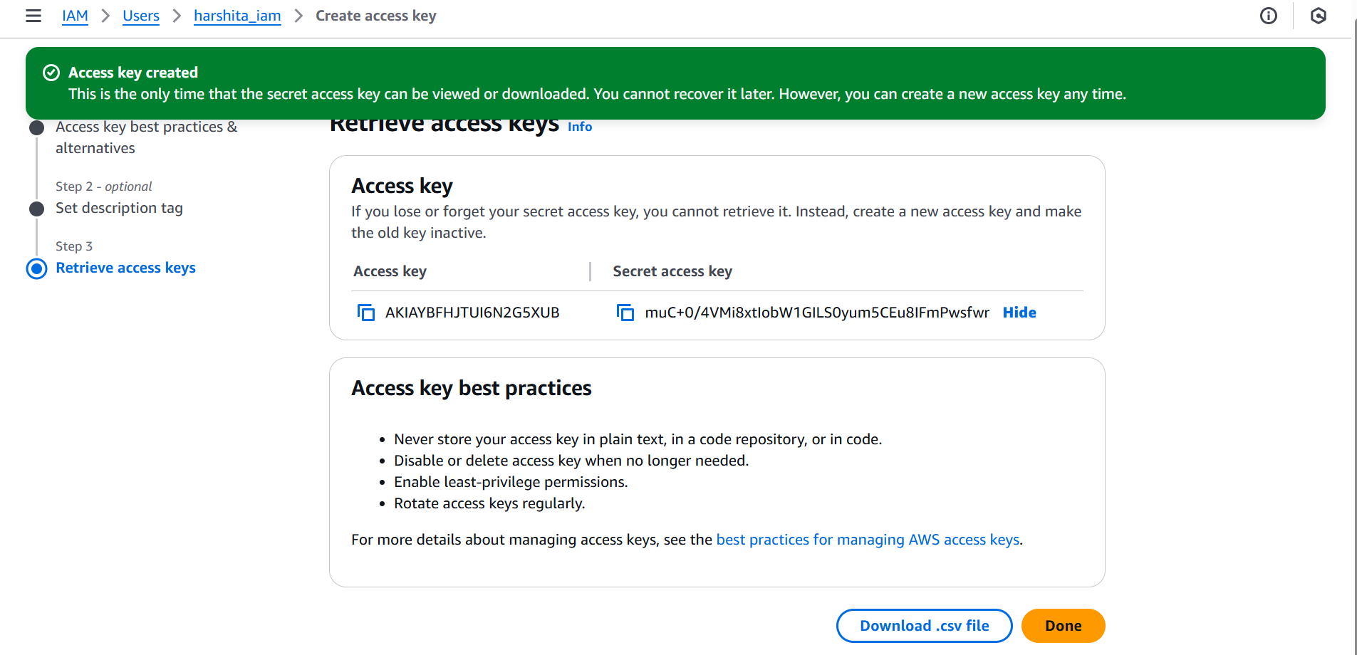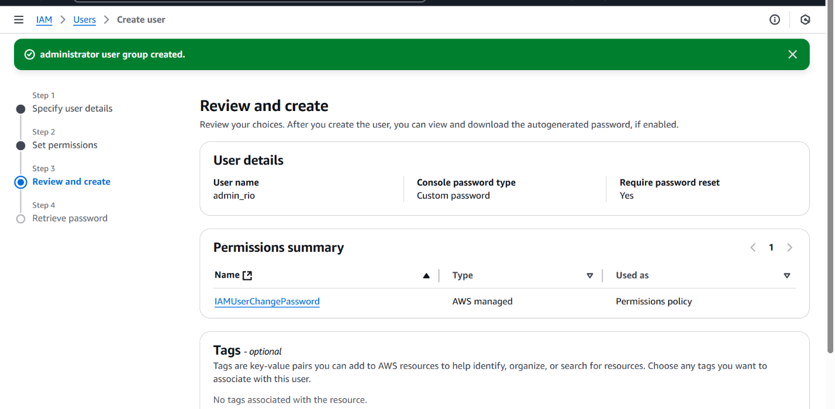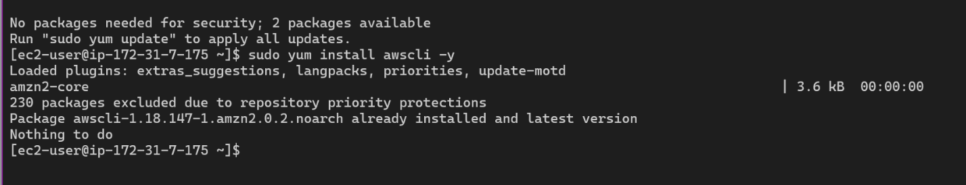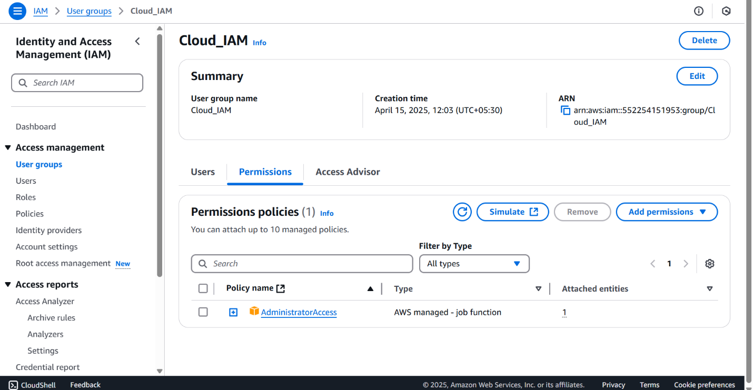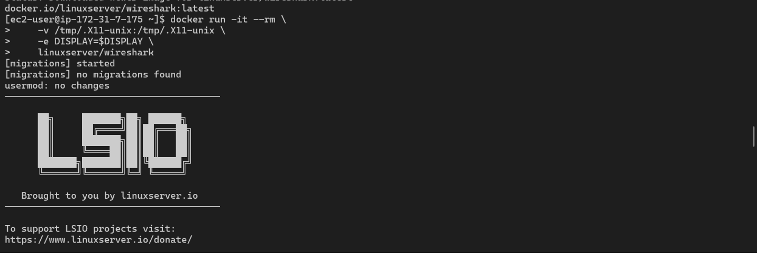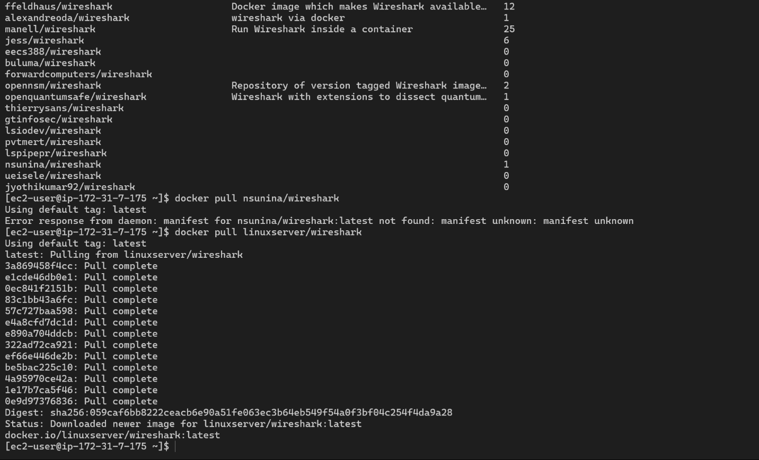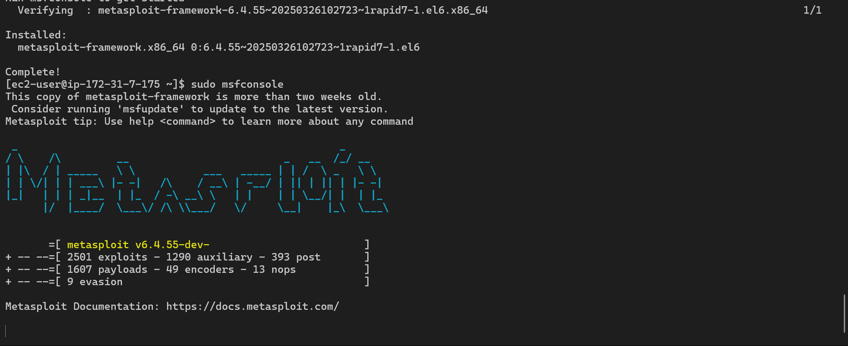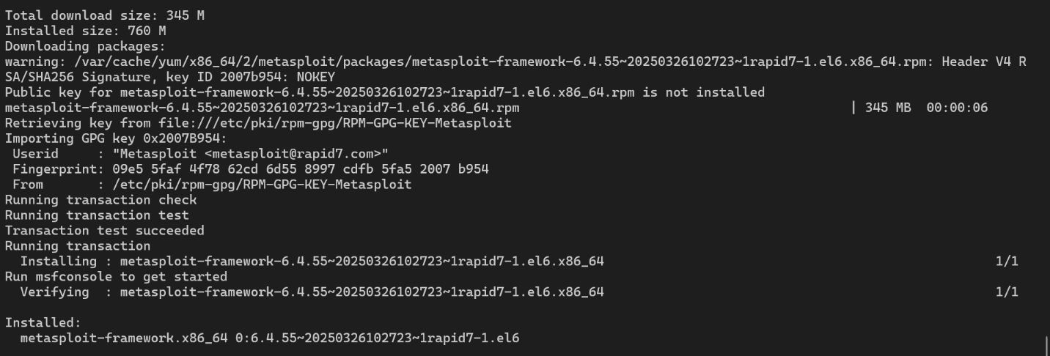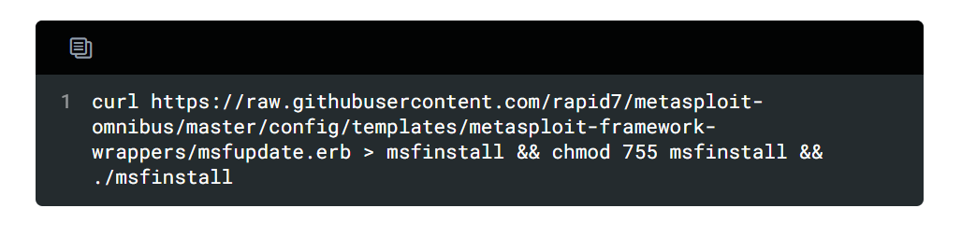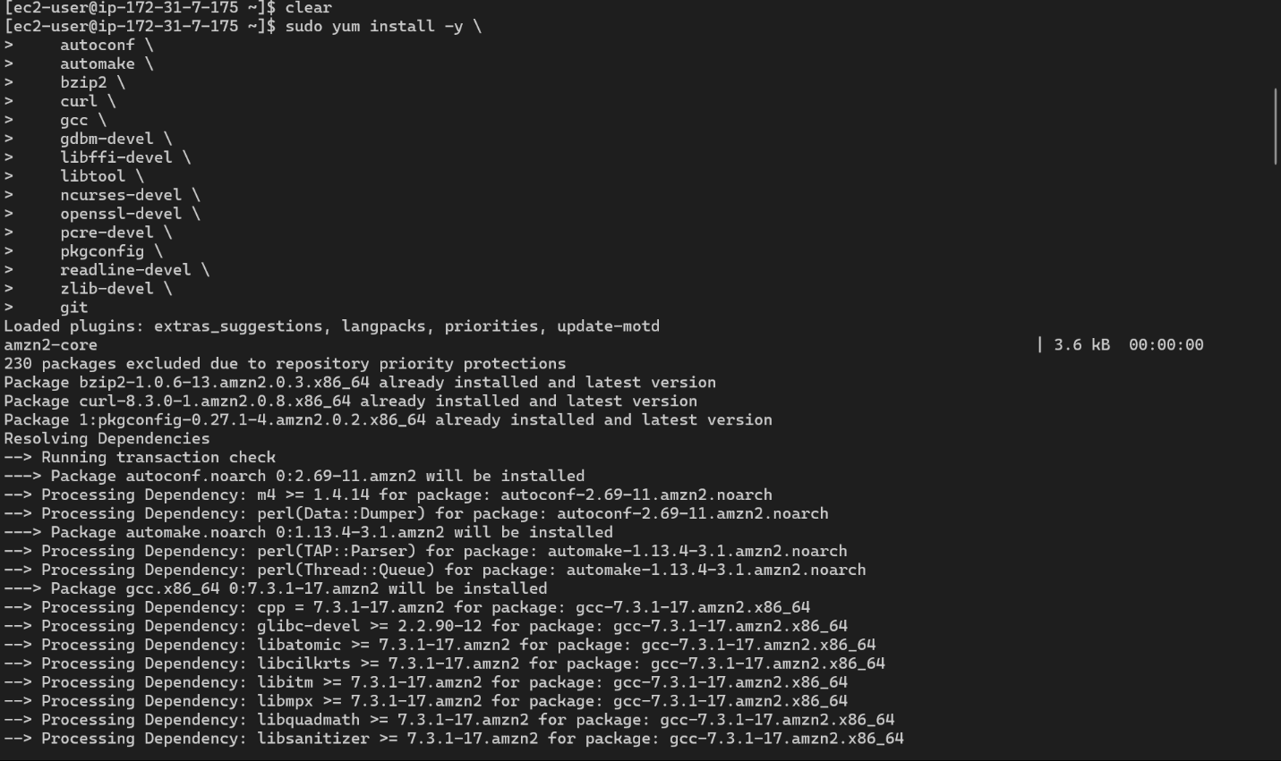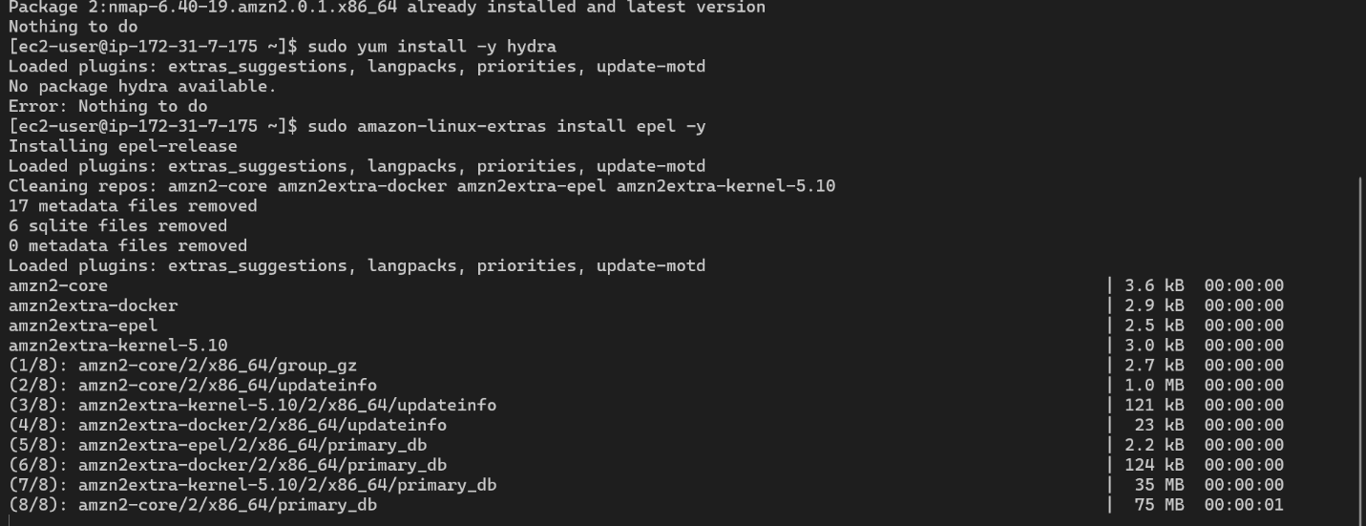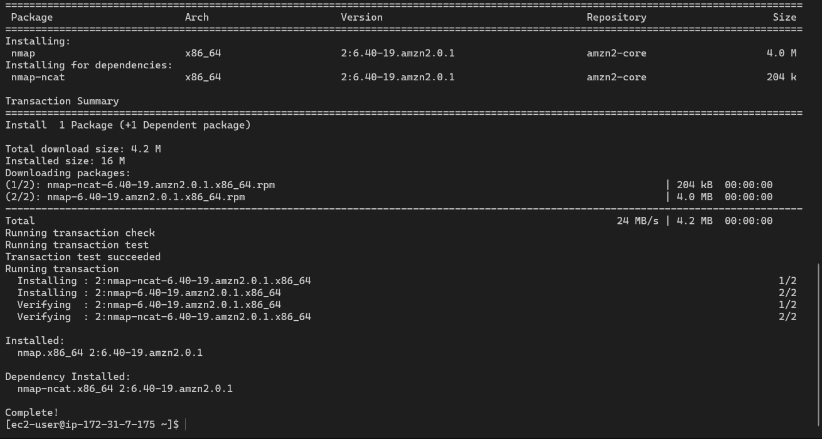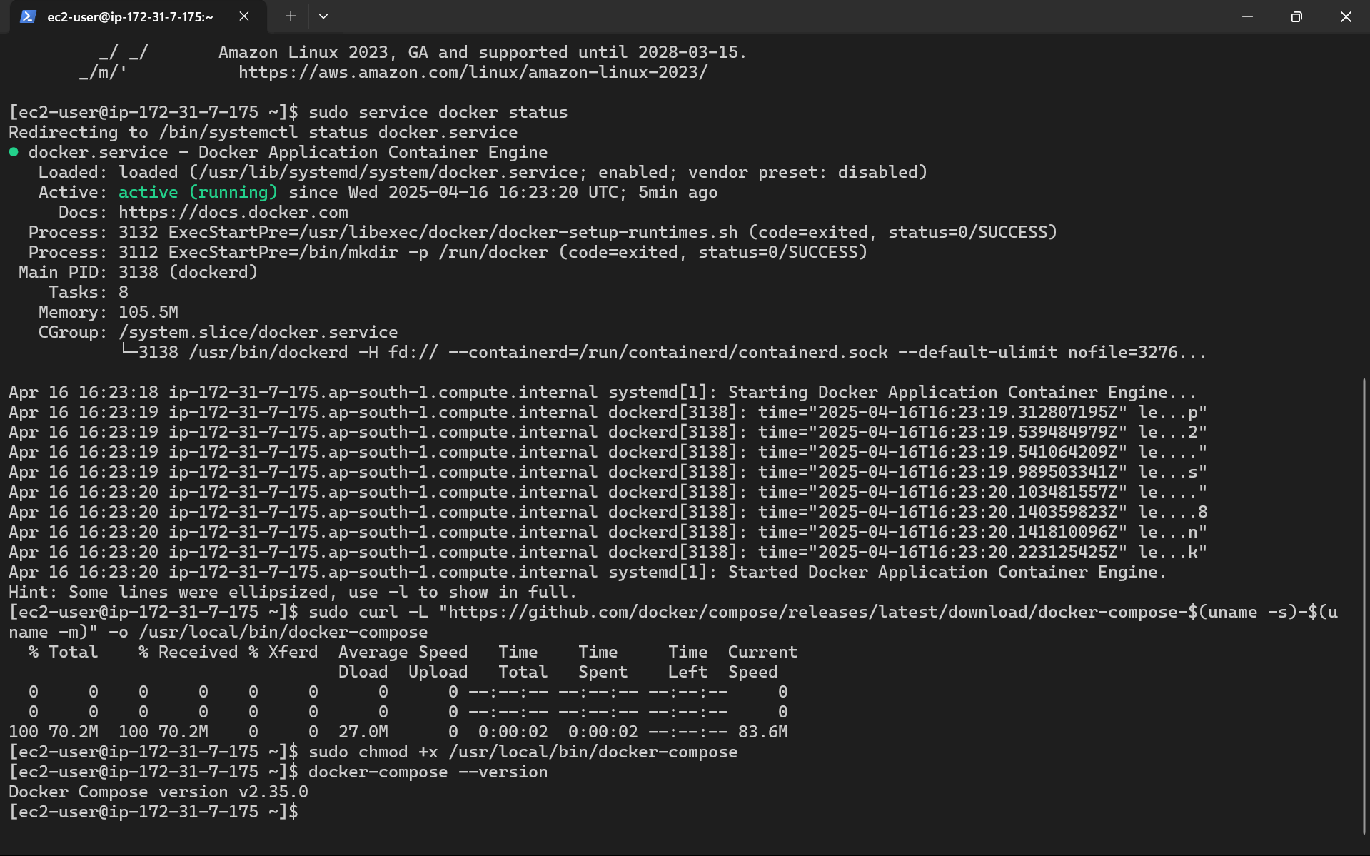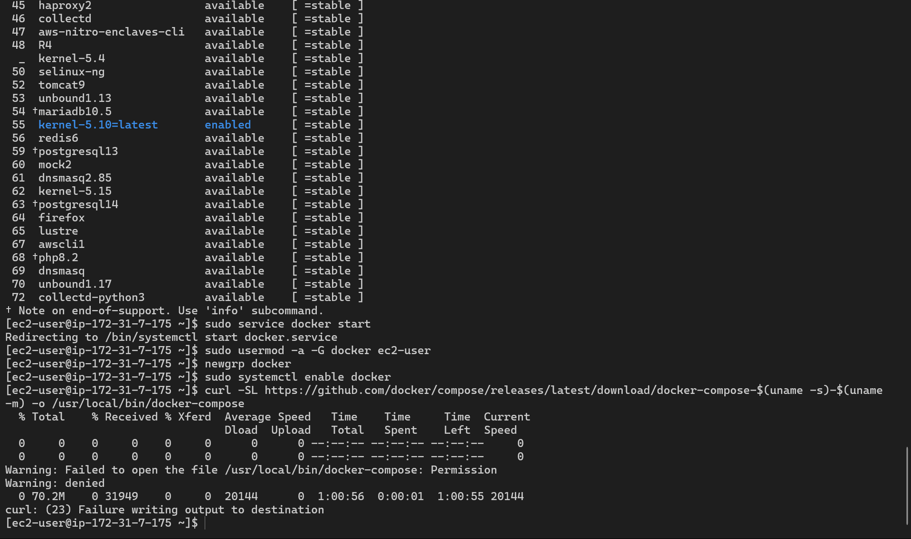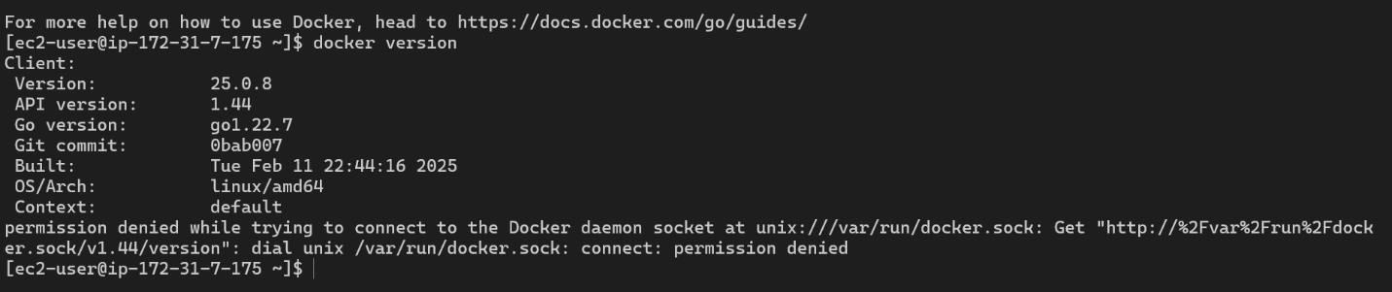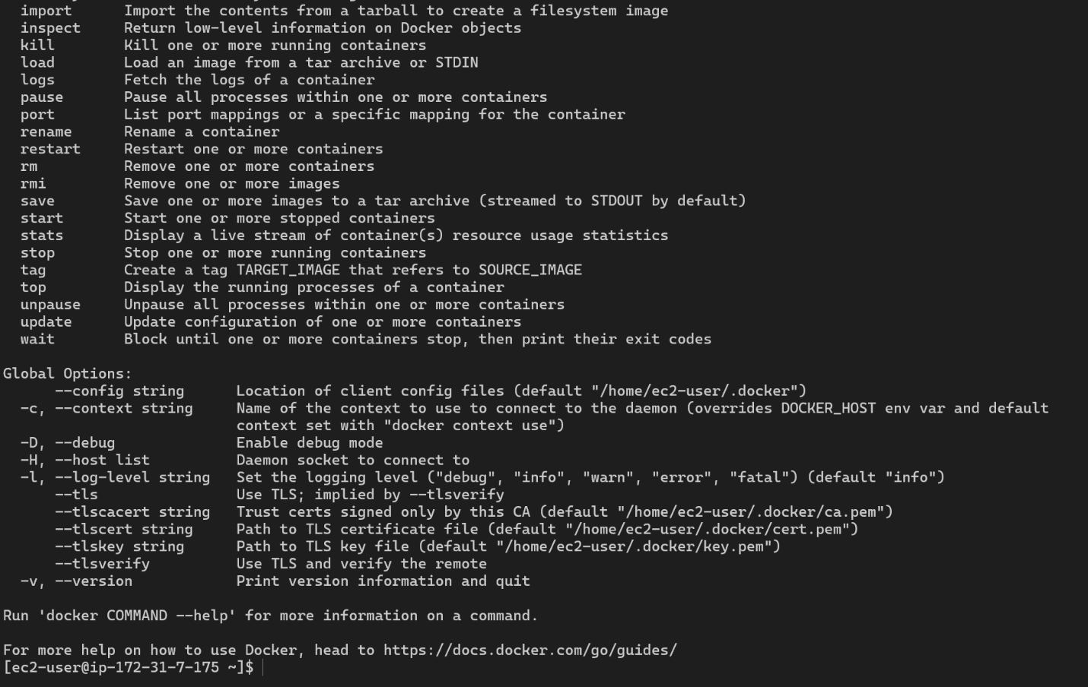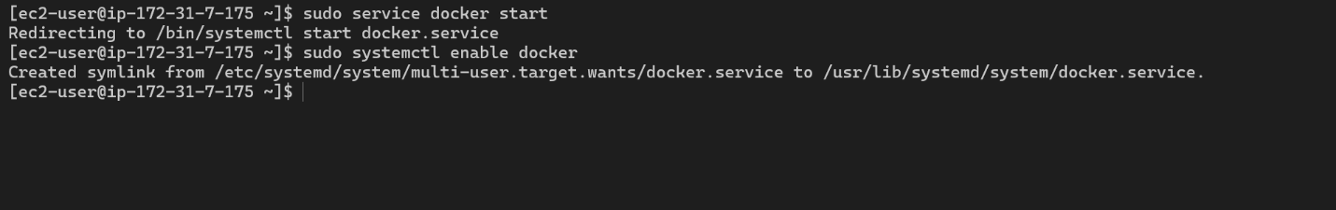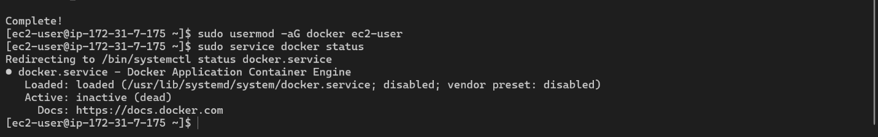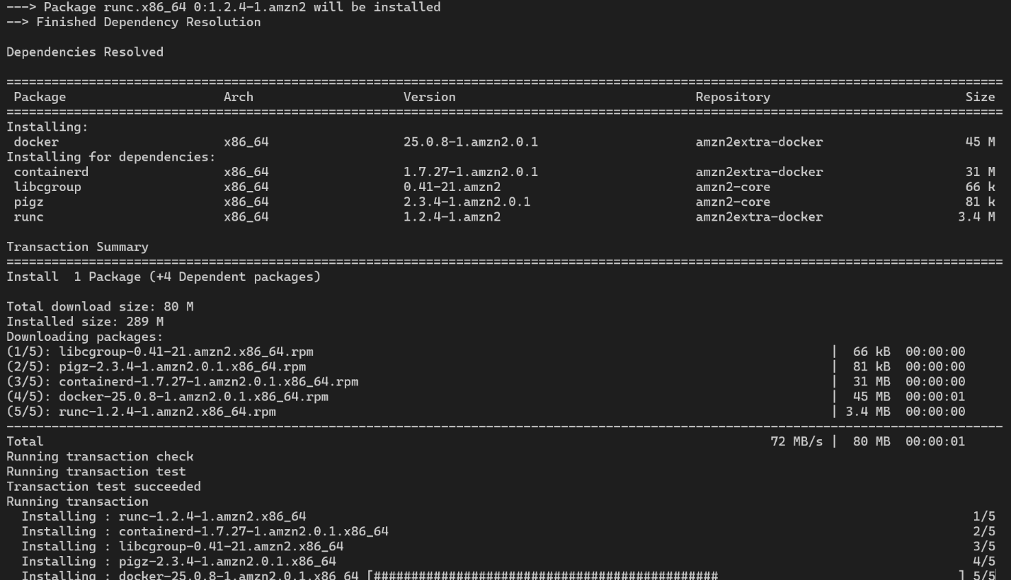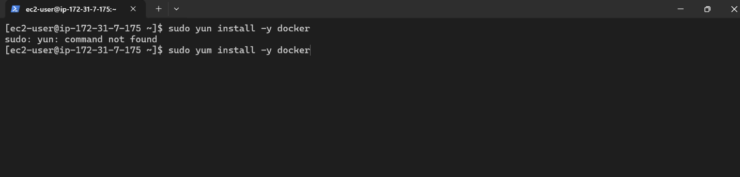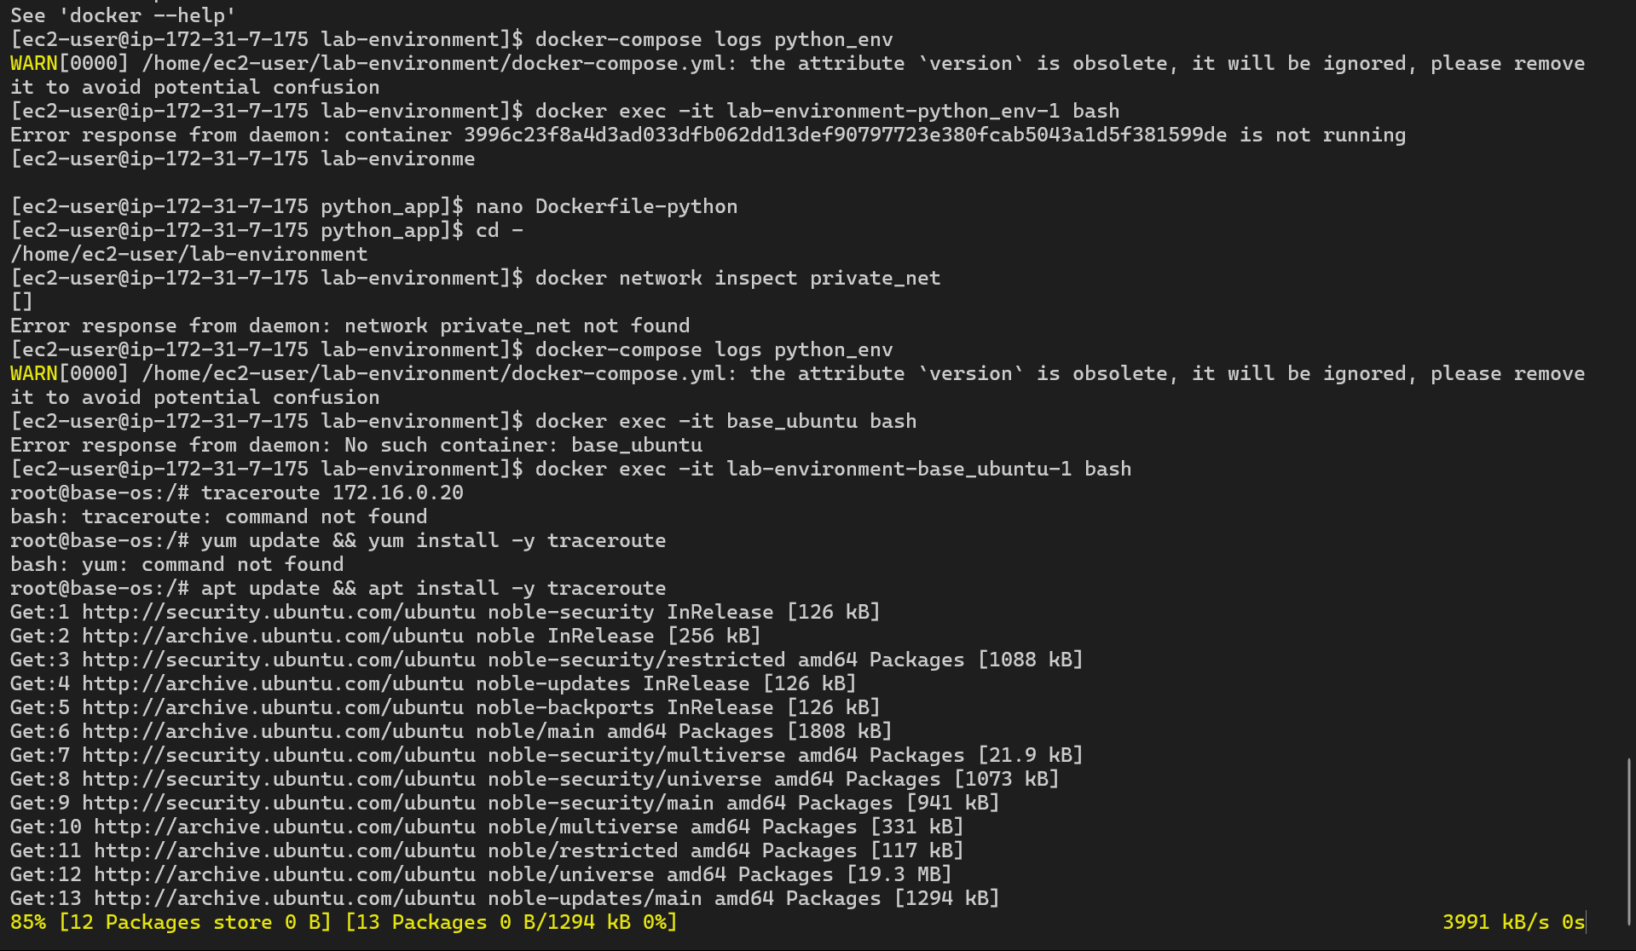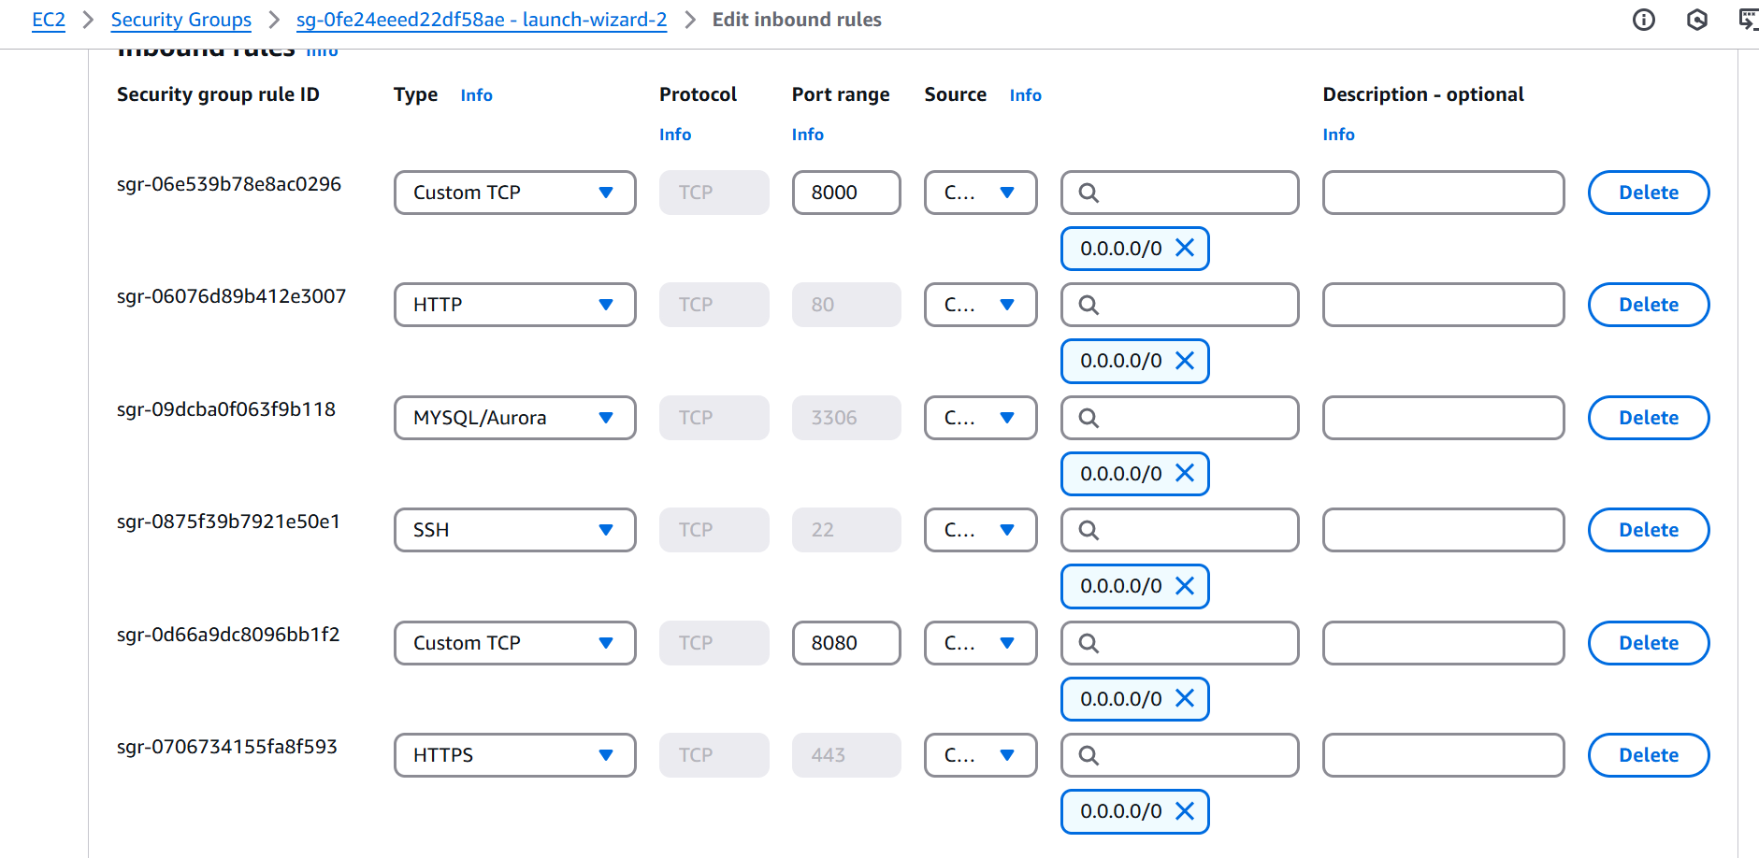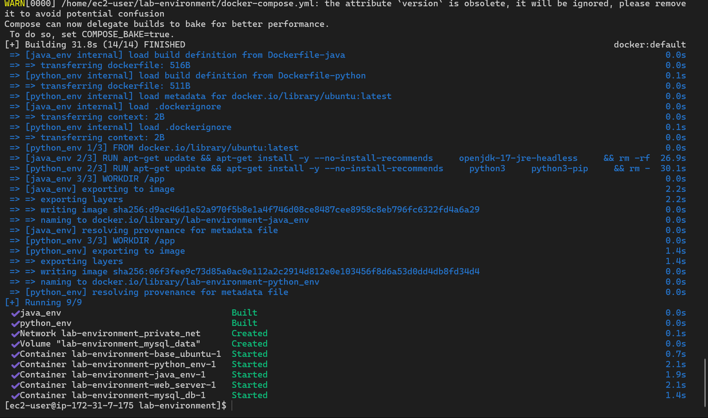

## Action Item 3: Vulnerability Scanning and Penetration Testing

### 3.1 Objective

The objective of this action item was to assess the security of the Docker environment by performing vulnerability scanning and penetration testing using various security tools.

### 3.2 Approach

The following steps were taken:

1. **Tool Installation:**
   * The following tools were installed on the EC2 instance:
     + nmap: For network scanning.
     + traceroute: For network path analysis.
     + hydra: For password cracking.
     + Metasploit Framework: For penetration testing.
     + Wireshark: For network packet analysis.

sudo yum install -y nmap traceroute hydra   
sudo amazon-linux-extras install epel -y  
sudo yum install -y nmap traceroute hydra   
curl https://raw.githubusercontent.com/rapid7/metasploit-framework/master/metasploit-install.sh > metasploit-install.sh  
chmod +x metasploit-install.sh  
sudo ./metasploit-install.sh  
docker pull kaazing/wireshark

1. **Vulnerability Scanning and Penetration Testing:**
   * traceroute was used to verify network connectivity between containers.
   * Nmap was used to scan the containers for open ports and services.
   * Metasploit Framework was used to perform port scans and vulnerability scanning.
   * Hydra and John were intended to be used for password cracking, but due to time constraints, this was not fully executed.
   * Wireshark was pulled as a docker image.

### 3.3 Logic Flow

1. The user connects to the EC2 instance via SSH.
2. The user installs the necessary security tools.
3. The user uses the tools to perform vulnerability scanning and penetration testing on the Docker environment.
4. The user analyzes the results.

### 3.4 Solutions and Templates

* **Nmap Scan Command:**  
  nmap -sV 172.16.0.40
* **Metasploit Console Launch:**  
  sudo msfconsole
* **Docker Run Wireshark:**  
  docker run -it --rm \  
   -v /tmp/.X11-unix:/tmp/.X11-unix \  
   -e DISPLAY=$DISPLAY \  
   --net=host \  
   --privileged \  
   nicolargo/wireshark

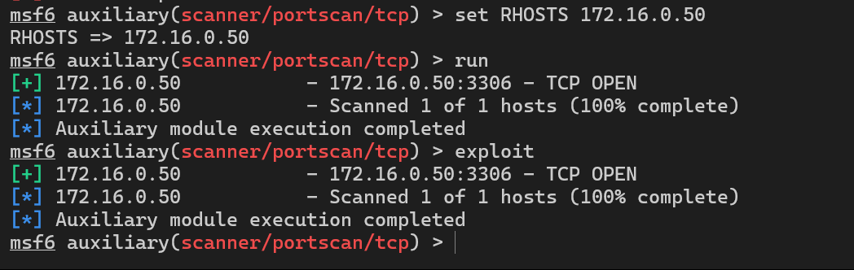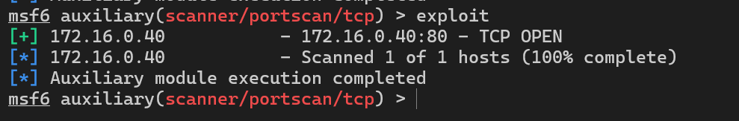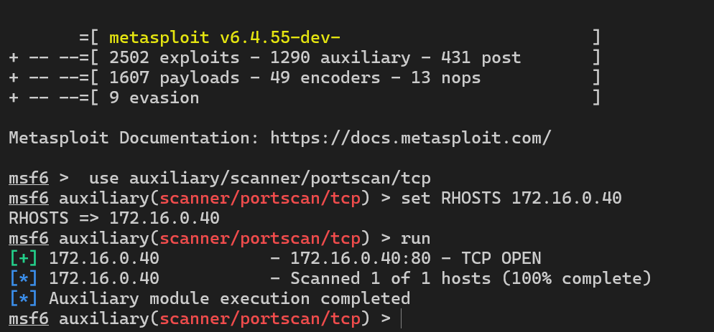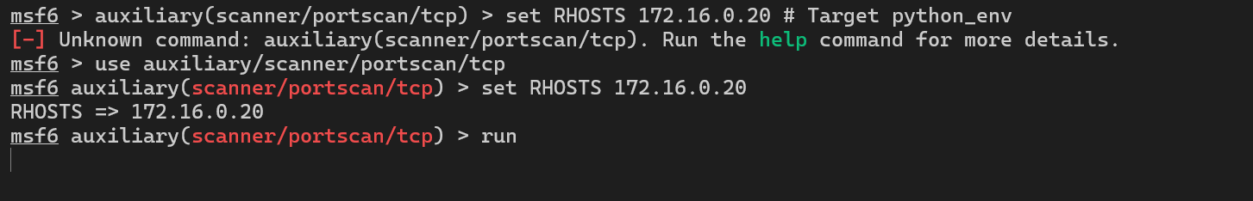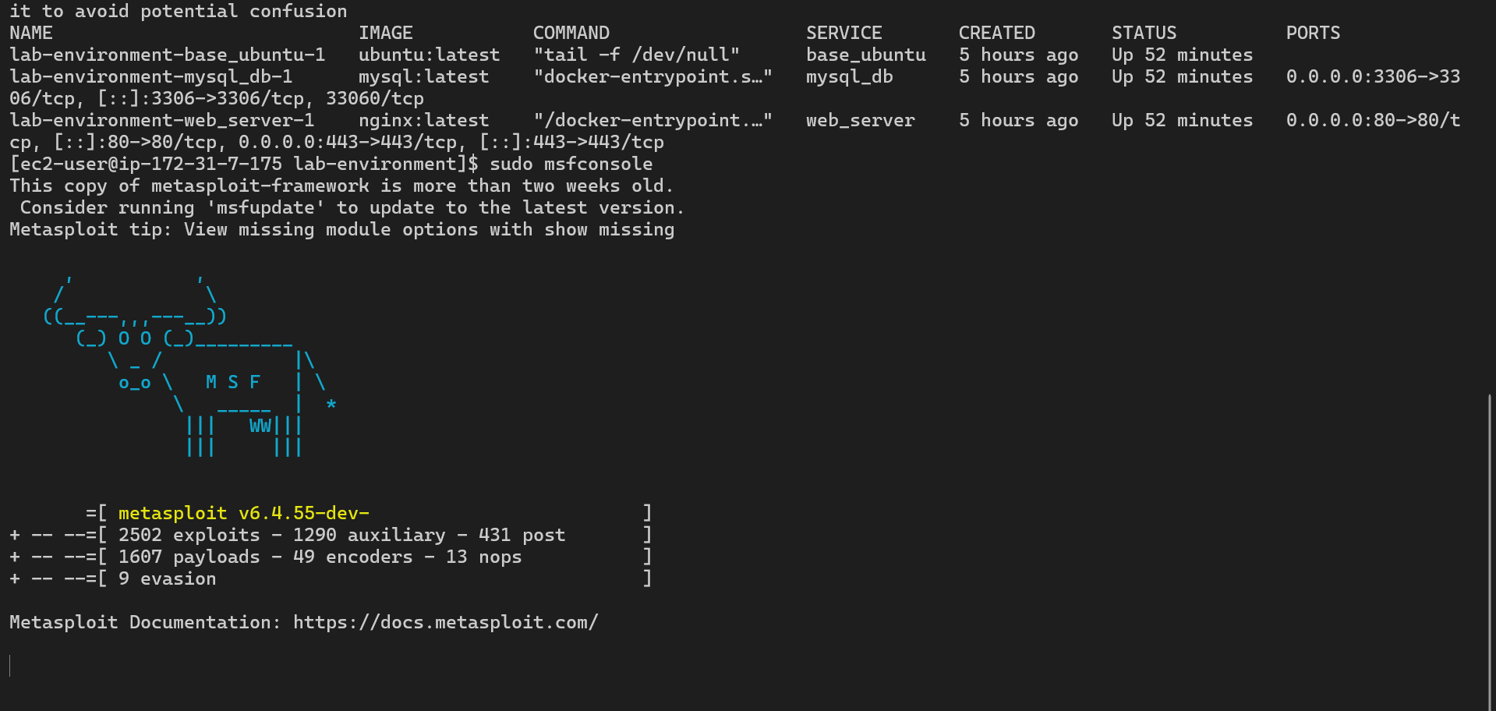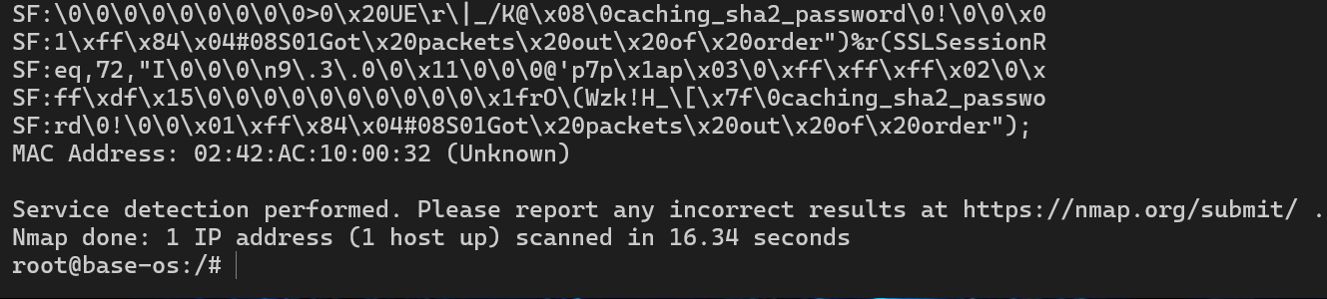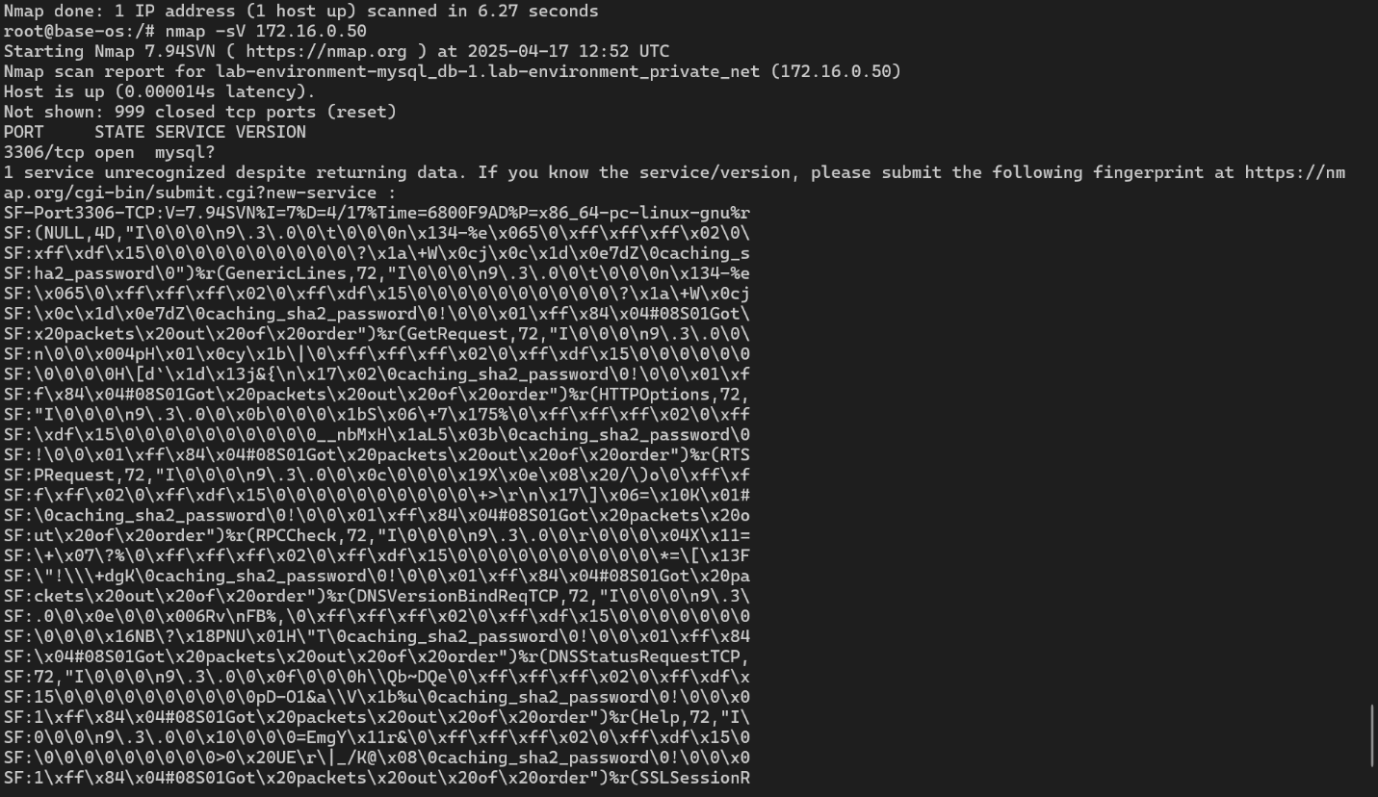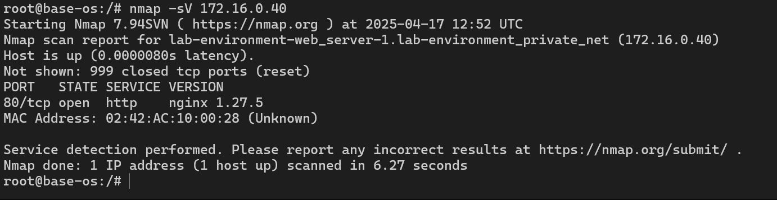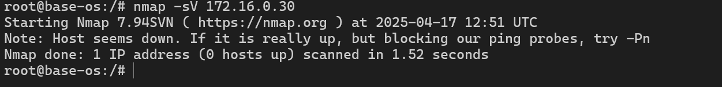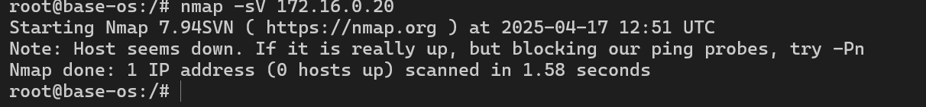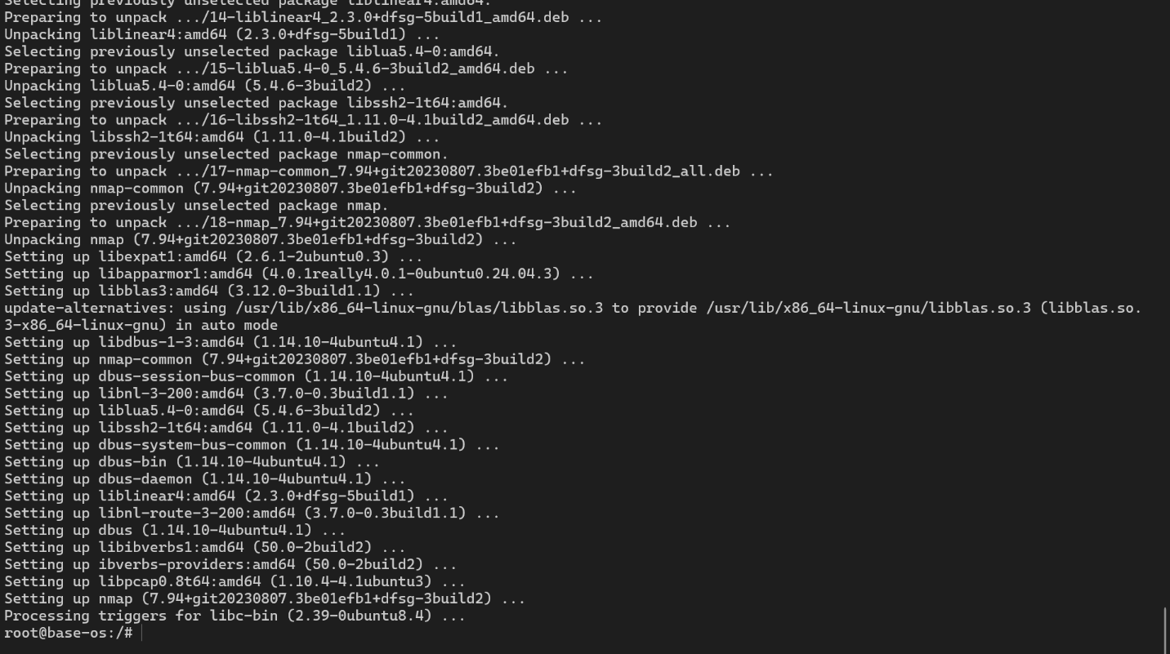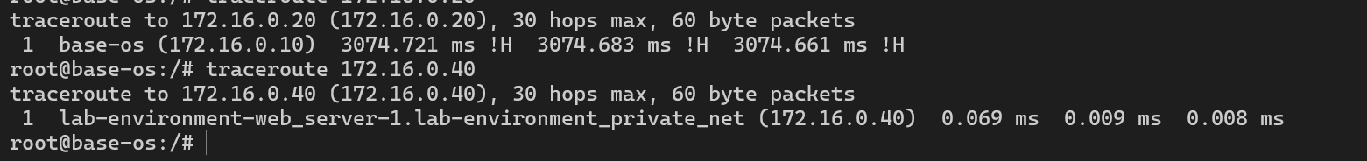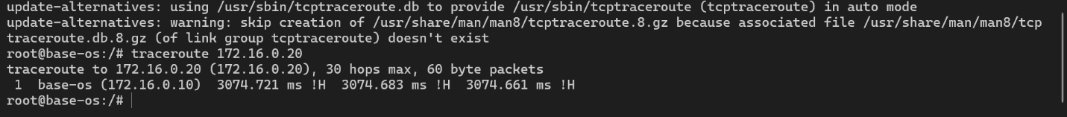

### 3.5 Challenges Faced

* Installing Metasploit Framework and its dependencies on Amazon Linux 2.
* Running Wireshark within a Docker container on a remote server.
* Repository issues with yum.
* Permission issues with the private key file.

### 3.6 Results and Outputs

* traceroute showed direct connectivity between containers.
* Nmap identified open ports and services on the containers.
* Metasploit Framework was installed and launched.
* Wireshark Docker image was pulled.
* Due to time constraints, full vulnerability scanning and password cracking were not completed.

## Enhancements Suggested

* **Automation:** Automate the setup process using tools like Ansible or Terraform.
* **Security Hardening:** Implement security best practices, such as:
  + Principle of Least Privilege for IAM users and container processes.
  + Regular security updates.
  + Strong password policies.
  + Network segmentation.
  + Use a reverse proxy and configure SSL.
* **Centralized Logging:** Implement centralized logging and monitoring for security auditing.
* **Automated Security Scanning:** Integrate automated vulnerability scanning into the CI/CD pipeline.
* **Detailed Documentation:** Expand documentation with more detailed steps and diagrams.
* **GUI Alternatives:** Explore alternative methods for running GUI applications in Docker on a remote server, or use command-line equivalents.
* **Complete Vulnerability Assessment**: Complete the vulnerability assessment and penetration testing.
* **Fix all vulnerabilities**: Based on the vulnerability assessment, fix all the vulnerabilities.
* **Implement a reverse proxy**: Implement a reverse proxy.
* **Configure SSL**: Configure SSL.
* **Regularly update**: Regularly update the system and the applications.
* **Document everything**: Document every step.

## Conclusion

The project successfully set up an AWS environment, a Docker environment, and initiated vulnerability scanning and penetration testing. While some challenges were encountered, the project provides a solid foundation for deploying and securing applications in a cloud-native environment. Further enhancements, particularly in the area of security automation and hardening, are recommended.

I would like to express my sincere gratitude for the opportunity to work on this project during my internship. I have gained valuable experience in cloud computing, containerization, and security best practices.

Thank you for your guidance and support.